# **TASK 1**

Create a webpage that includes a scrolling header message, a table displaying details of your favorite movies (such as name, genre, year, and rating), an image of your favorite actor/actress, a movie trailer video with controls, and an audio player for a movie soundtrack that auto-plays when the page loads.

<!DOCTYPE html>

<html>

<head>

<title>Prabhas Fan Movie Page</title></head>

<body>

<marquee><h3>🎬 Welcome To Movie fan page! 🎬</h3></marquee>

<table border="2" width="150px" padding="10px">

<thead>

<tr>

<th>Movie Name</th>

<th>Genre</th>

<th>Year</th>

<th>Rating</th>

</tr>

</thead>

<tbody>

<tr>

<td>Pushpa: The rule</td>

<td>Action, Fantasy</td>

<td>2017</td>

<td>8.2/10</td>

</tr>

<tr>

<td>HIT3</td>

<td>Action, Thriller</td>

<td>2025</td>

<td>--/10</td>

</tr>

<tr>

<td>Game Changer</td>

<td>Action , Drama</td>

<td>2024</td>

<td>5.4/10</td>

</tr>

</tbody>

</table>

<!-- Allu Arjun Image -->

<img src="C:\Users\aruns\Desktop\Allu-Arjun-3.webp" alt="allu arjun" class="center" width="100"></img>

<!-- Nani Image -->

<img src="C:\Users\aruns\Desktop\HIT 3.jpg" alt="Nani" class="center" width="100"></img>

<!-- Ram Charan Image -->

<img src="C:\Users\aruns\Desktop\rc.jpg" alt="Ram charan" class="center" width="100"></img>

<!-- Pushpa Trailer -->

<iframe class="center" width="200" height="250"

src="https://www.youtube.com/watch?v=Q1NKMPhP8PY&pp=ygUVcHVzaHBhIHRyYWlsZXIgdGVsdWd1"

allow="accelerometer; autoplay; clipboard-write; encrypted-media; gyroscope; picture-in-picture"

allowfullscreen>

</iframe>

<!-- HIT3 Trailer -->

<iframe class="center" width="200" height="250"

src="https://www.youtube.com/watch?v=kAtfaaUgDRU&pp=ygUUaGl0IDMgdHJhaWxlciB0ZWx1Z3U%3D"

allow="accelerometer; autoplay; clipboard-write; encrypted-media; gyroscope; picture-in-picture"

allowfullscreen>

</iframe>

<!-- Game Changer Trailer -->

<iframe class="center" width="200" height="250"

src="https://www.youtube.com/watch?v=zHiKFSBO_JE&pp=ygUbZ2FtZSBjaGFuZ2VyIHRyYWlsZXIgdGVsdWd1"

allow="accelerometer; autoplay; clipboard-write; encrypted-media; gyroscope; picture-in-picture"

allowfullscreen>

</iframe>

<h3>Pushpa: The rule</h3>

<audio src="C:\Users\aruns\Downloads\Dakko Dakko Meka.mp3" controls></audio>

</body>

</html>

**OUTPUT:**

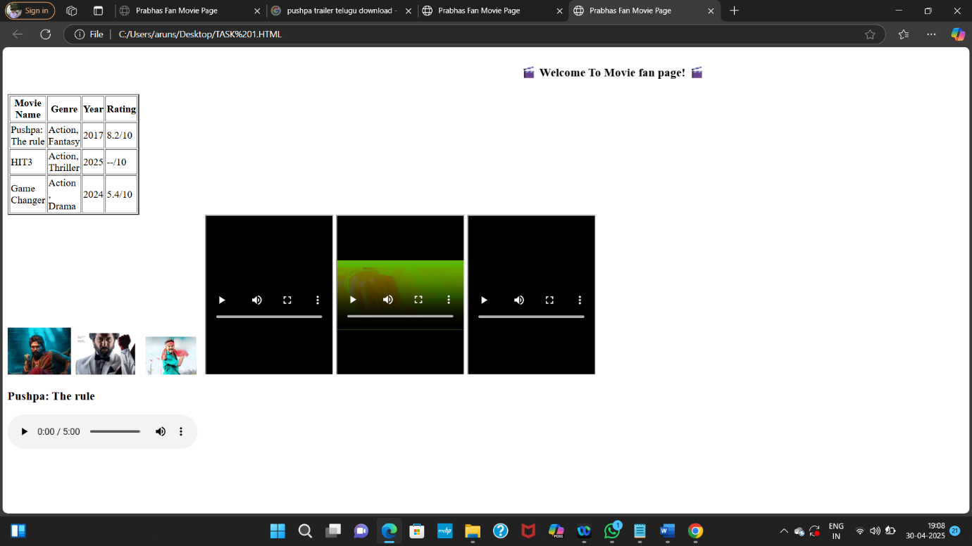

# **TASK 2**

Design a webpage that includes a horizontal navigation menu with links to "Home," "About," "Services," and "Contact," followed by a section that displays a list of your favorite books in a neat table with columns for Title, Author, and Genre. Below the table, insert an image of the book cover for one of the books, a video review of the book, and an audio clip of an author interview.

<!DOCTYPE html>

<html>

<head>

<title>Task 2</title>

</head>

<body>

<h2>[Home] [About] [Services] [Contact]</h2>

<table border="9" style="padding: 20px;">

<tr>

<th>MAGAZINE TITLE</th>

<th>AUTHOR</th>

<th>GENRES</th>

<th>LAUNCHED DATE</th>

<th>OVERVIEW</th>

</tr>

<tr>

<td>Wednesday</td>

<td>Charles Addams</td>

<td>teen drama, fantasy, mystery, and dark comedy</td>

<td>2023</td>

<td> a teenage Addams family member, attending Nevermore Academy, a boarding school for outcasts and monsters.</td>

</tr>

<tr>

<td>Harrypotter</td>

<td>J.K. Rowling</td>

<td>urban and contemporary fantasy</td>

<td>2007</td>

<td>'The Potter' is a story which tells about the lineage of the great Harry Potter.</td>

</tr>

<tr>

<td>End Game</td>

<td>Christopher Markus and Stephen McFeely</td>

<td>Action, Sci-fi, Super hero, Adventure, Fantasy</td>

<td>2019</td>

<td>End of main Avengers.</td>

</tr>

</table>

<h2>Harrypotter</h2>

<img src="C:\Users\aruns\Desktop\harrypotter.avif"alt="Harry potter Image" height="200" width="250">

<h2>Wednesday</h2>

<iframe width="300" height="250"

src="C:\Users\aruns\Desktop\wednesday.jpg" allowfullscreen>

</iframe>

<h3>doramon theme song</h3>

<audio controls>

<source src="C:\Users\aruns\Downloads\Doraemon.mp3"audio/mpeg"">

</audio>

</body>

</html>

**OUTPUT:**

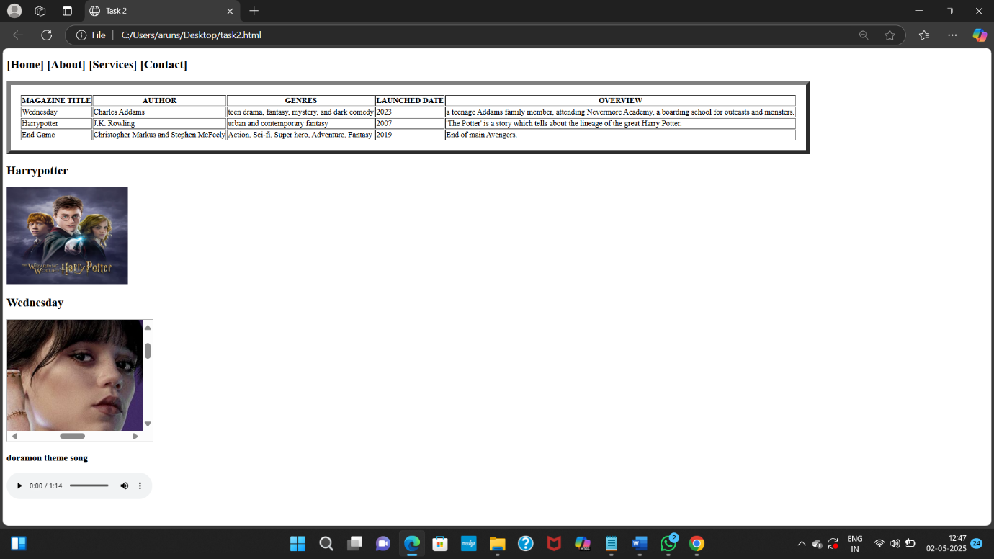

# **TASK 3**

Create a portfolio webpage with a header that scrolls a welcome message across the screen, followed by a section that includes a table of your recent projects with columns for Project Name, Description, and Date. Below the table, add an image of a screenshot from one of the projects, a video tutorial on the project, and an audio description of the project.

<!DOCTYPE html>

<html>

<head>

<title>My Portfolio</title>

</head>

<body>

<marquee behavior="scroll" direction="left"><h1>Welcome to My Portfolio!</h1></marquee>

<h2>Recent Projects</h2>

<table border="7px" padding="20px" height="50">

<tr>

<th>Project Name</th>

<th>Description</th>

<th>Date</th>

</tr>

<tr>

<td>producing electricity from heat</td>

<td>Develop the server-side logic for an app</td>

<td>August 2024</td>

</tr>

</table>

<h3>Video Tutorial</h3>

<iframe class="center" width="800" height="450" controls

src="C:\Users\aruns\Desktop\producing electricity from heat.mp4">

</iframe>

<h3>Audio Description</h3>

<audio controls

src="C:\Users\aruns\Desktop\audio task 3.unknown">

Your browser does not support the audio element.

</audio>

</body>

</html>

**OUTPUT:**

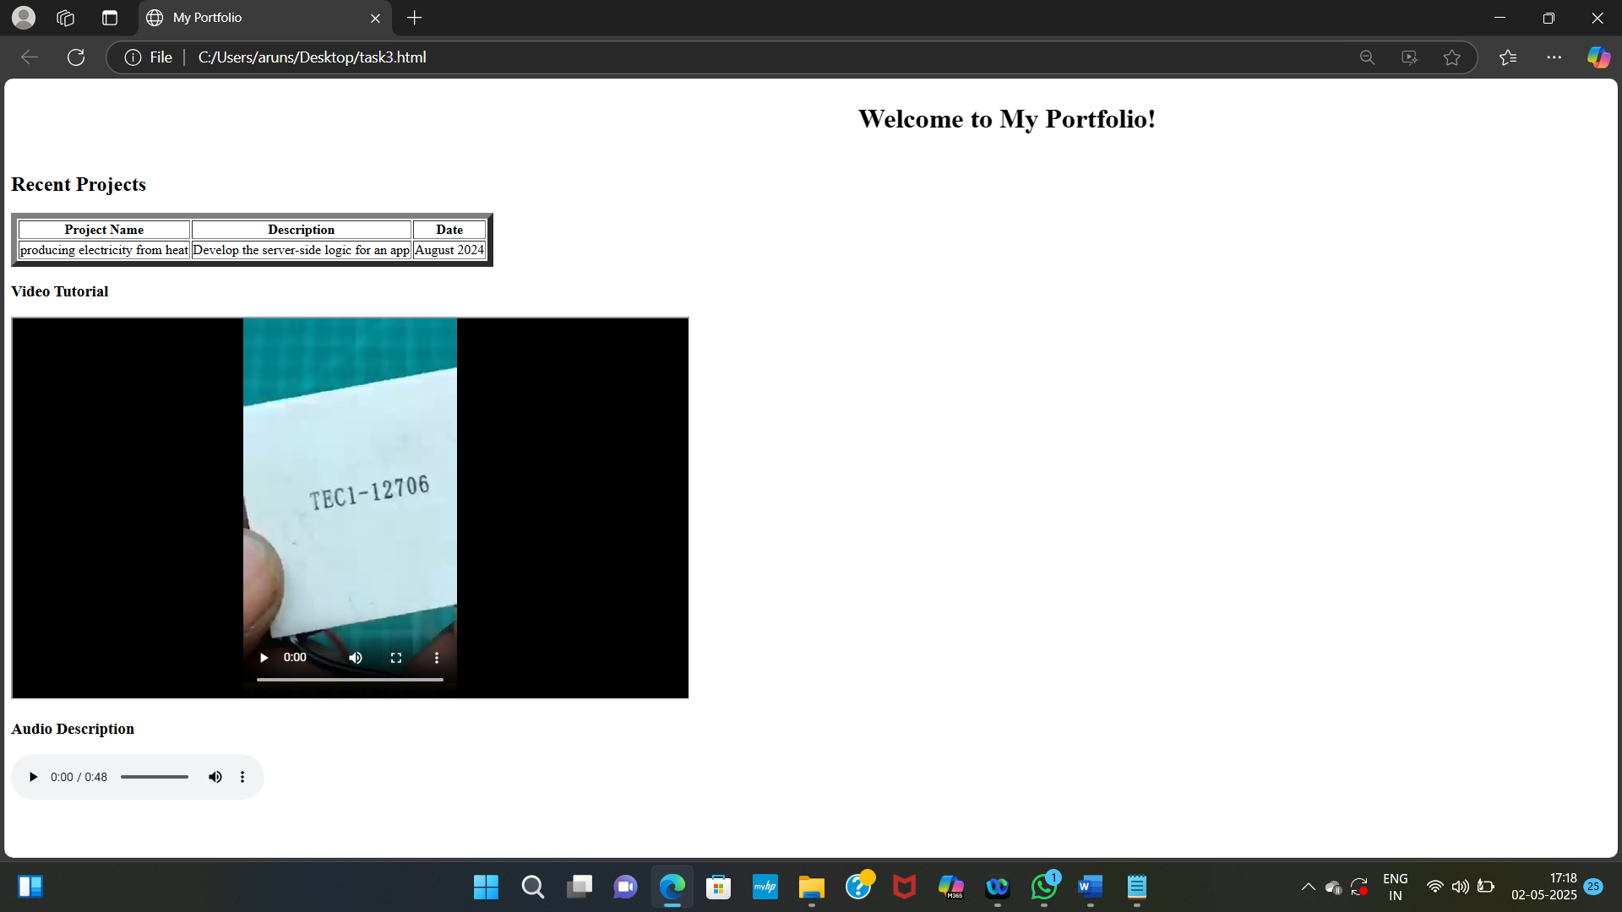

# **TASK 4**

Create a basic HTML page introducing yourself. Design a webpage using appropriate HTML tags that displays:

• Your full name as a heading

• A short paragraph describing yourself

• A list of your hobbies using an unordered list

<!DOCTYPE HTML>

<html>

<head>

<title>Self Introduction</title>

</head>

<body>

<h1>Arunsai</h1>

<p>

Hai! This is arunsai. I am studying in Aditya Degree College in 2nd year and i belongs to nuclear family. My strength are in self motivating person and i have strong communication skill also. My short term goal is get a job in a reputed company.

</p>

<h2>My Hobbies</h2>

<ul>

<li>playing games</li>

<li>roaming</li>

<li>watching movies</li>

</ul>

</body>

</html>

**OUTPUT:**

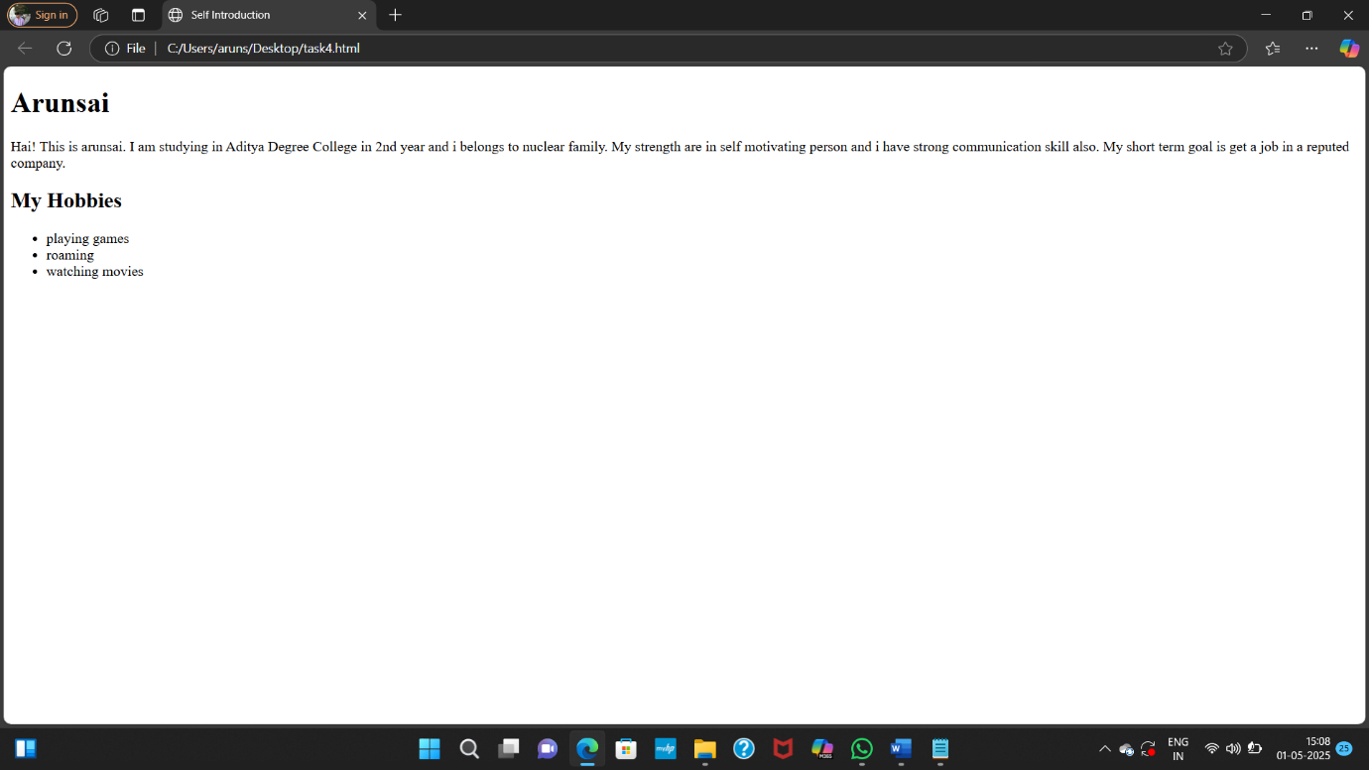

# **TASK 5**

Create a simple resume web page using HTML.

The resume should include:

• Your name in a **tag**

**• A bio/summary using the tag**

**• A list of your skills using an unordered list**

**• A list of your qualifications using an ordered list**

<!DOCTYPE HTML>

<html>

<head>

<title>My Resume</title>

</head>

<body>

<h1>SK.Vali Basha</h1>

<p> I am currently looking for opportunity where i can grow the best company

and i enjoy real-world projects and problem solving in coding</p>

<ul>

<h2><b>Skills</b></h2>

<li>communication</li>

<li>Problem Solving</li>

<li>Presentation</li>

</ul>

<ol>

<h2><b>Qualifications</b></h2>

<li>bachelor of Computer Sciene</li>

<li>MSN intermideate completed 43%</li>

<li>SSRK School 93%</li>

</ol>

</body>

</html>

**OUTPUT:**

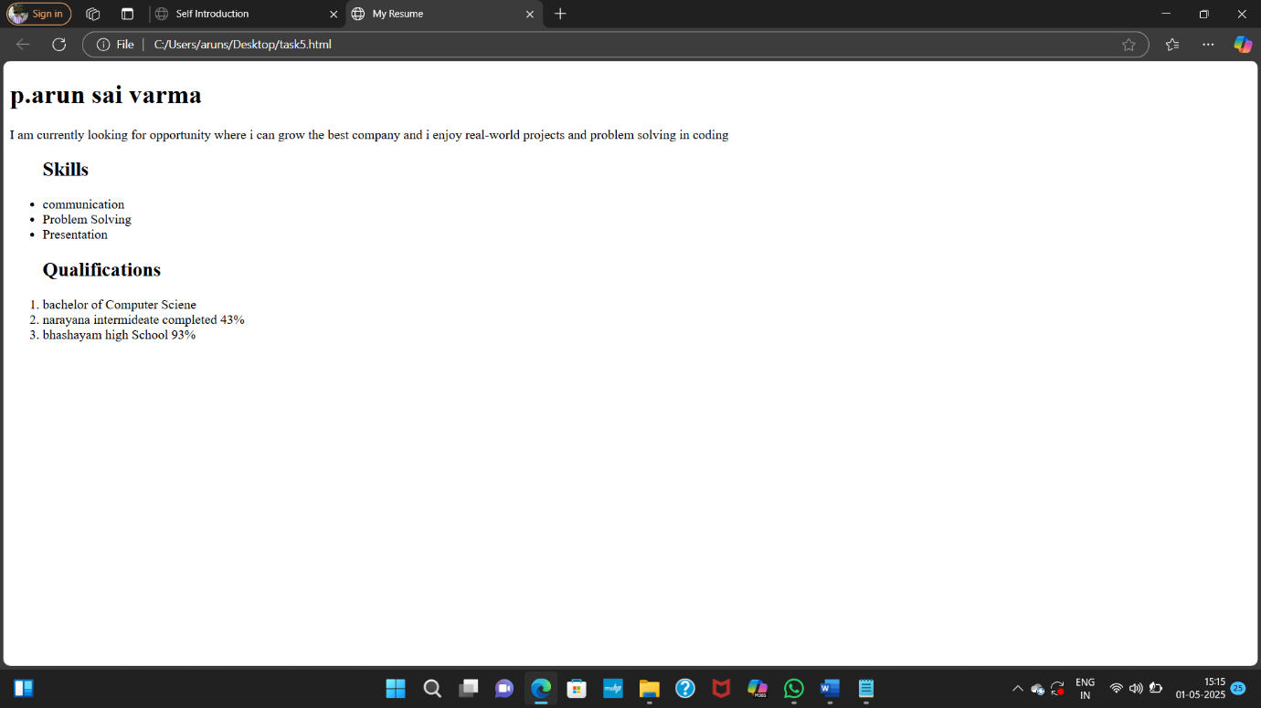

# **TASK 6**

Create a paragraph demonstrating the following text forma ng tags:

Use the following tags in a single paragraph and observe their effect on text appearance:

• <b>, <strong>, <i>, <em>, <u>, <mark>, <small>

<!<!DOCTYPE HTML>

<html>

<head>

<title>Text formatting tags</title>

</head>

<body>

<h3><b>Text appearence</b></h3>

<p>

<b>"Adhoc company"</b> ,The CEO of Adhoc Network Tech company is <strong>Devika Pakruthi</strong>. She is also the <i>company's founder</i>.She is featured on <em>Linkedln</em>and her instagram account is<u>ceo_devika.</u> She is a <mark>Leading entrepreneur</mark> in the software industry. She founded Adhoc Network at the age of<small>22</small> to show reduced emphasis.

</p>

</body>

<html>

**OUTPUT:**

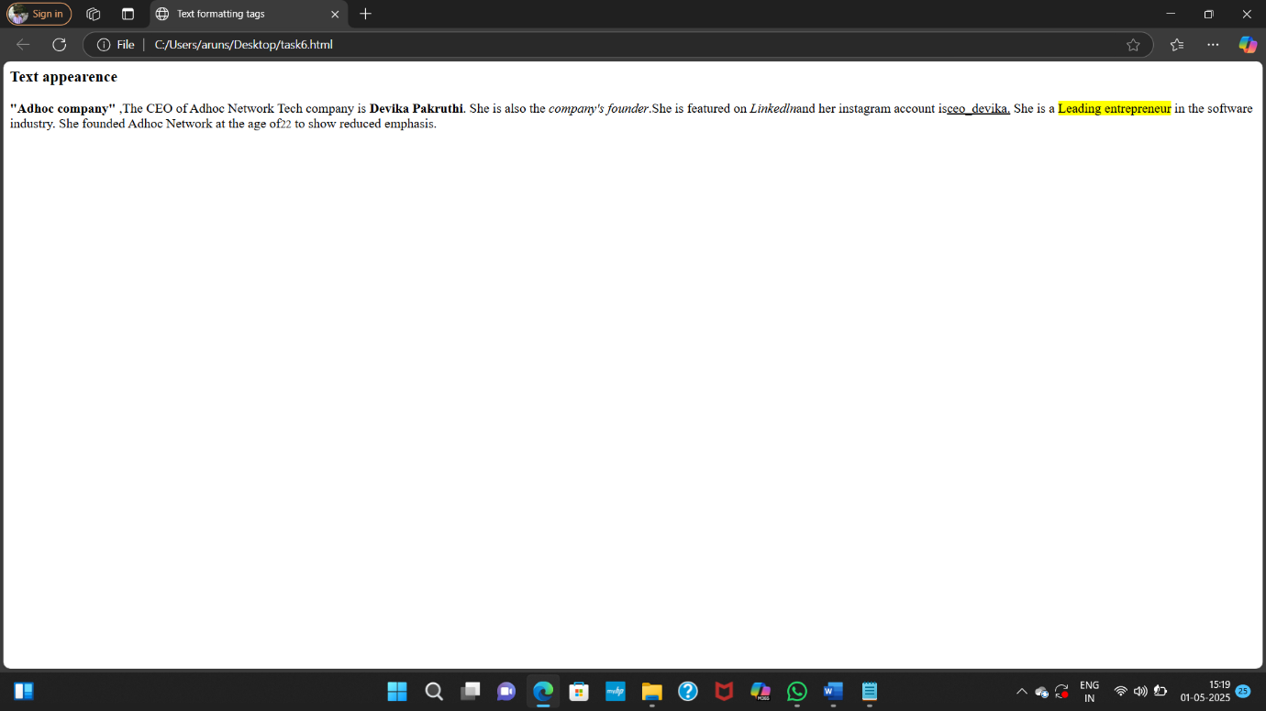

# **TASK 7**

Create a nested list of a shopping category.

The main list should have categories like Fruits, Vegetables, Electronics.

Each category should include 3 relevant items using nested lists.

<!<!DOCTYPE HTML>

<html>

<head>

<h2>Shopping Category<h2>

</head>

<body>

<h3><b>Fruits</b></h3>

<ol>

<li>avacado</li>

<li>mango</li>

<li>blueberry</li>

</ol>

<h3><b>Vegetables</b></h3>

<ol>

<li>bottlecard</li>

<li>ladiesfinger</li>

<li>greenpeas</li>

</ol>

<h3><b>Electronics</b></h3>

<ol>

<li>laptop</li>

<li>headphone</li>

<li>joystick</li>

</ol>

</body>

</html>

**OUTPUT:**

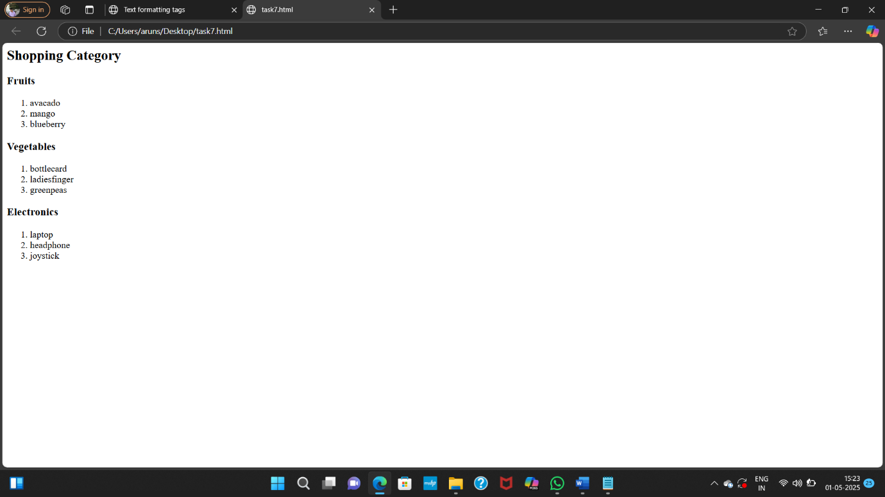

# **TASK 8**

Create an ordered list of your semester subjects.

• Use roman numerals for list markers

• Start the numbering from IV using the start attribute

<!DOCTYPE HTML>

<html>

<head>

<h2>4th Sem Subjects</h2>

<ol type="a">

</head>

<body>

<ol type="I" start="4">

<li>Amazon Web Service</li>

<li>Data Communication Network</li>

<li>Database Management Systems</li>

<li>Computer Networks Electronics</li>

<li>object oriented Software Engineering</li>

</ol>

</body>

</html>

**OUTPUT:**

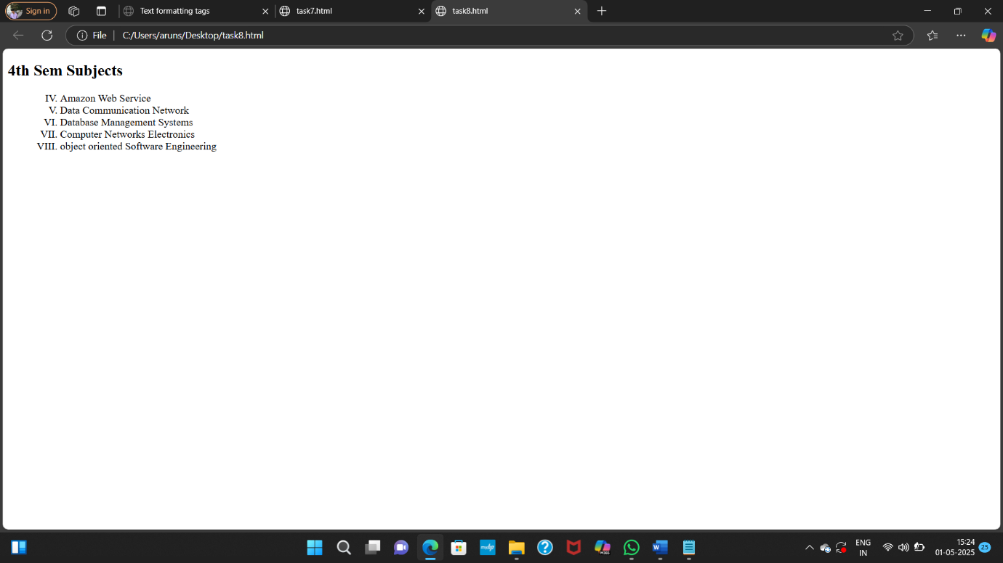

# **TASK 9**

Create a student marks table using HTML table tags.

Your table should contain the following columns:

• Name, Subject, Marks, Grade Use for headers<th> and for table data<td>.

<!DOCTYPE HTML>

<html>

<head>

<h2>Student Marks Table</h2>

</head>

<body>

<table border="1">

<tr>

<th>Name</th>

<th>Subject</th>

<th>Marks</th>

<th>Grade</th>

</tr>

<tr>

<td>Arun</td>

<td>Coputer Science</td>

<td>99</td>

<td>A+</td>

</tr>

<tr>

<td>Santhosh</td>

<td>computer Science</td>

<td>90</td>

<td>A+</td>

</tr>

<tr>

<td>pawan</td>

<td>data science</td>

<td>90</td>

<td>A+</td>

</tr>

<tr>

<td>balu</td>

<td>BCA</td>

<td>99</td>

<td>O</td>

</tr>

</table>

</body>

</html>

**OUTPUT:**

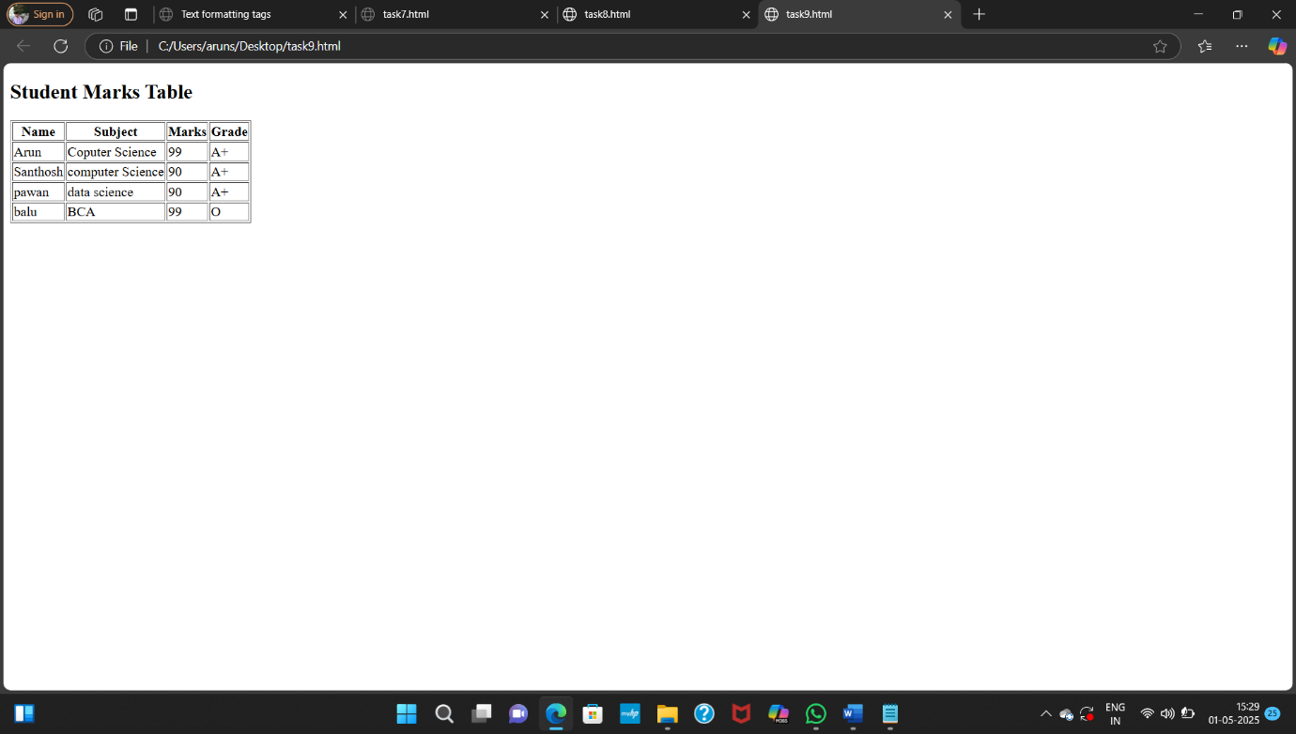

# **TASK 10**

Create a webpage that displays two images using the **Error! Filename not specified.**tag.

• One image should be sized to 300x300px

• The other image should be 500x400px

• Include the alt attribute to show alternate text if the image doesn't load

<!DOCTYPE html>

<html>

<head>

<h1>Webpage Display Images</h1>

</head>

<body>

<h2>Image 1 (300x300)</h2>

<img src="C:\Users\aruns\Desktop\bunny.jfif" width="300" height="300" alt="Description of image 1">

<h2>Image 2 (500x400)</h2>

<img src="C:\Users\aruns\Desktop\HIT 3.jpg" width="500" height="400" alt="Description of image 2">

</body>

</html>

**OUTPUT:**

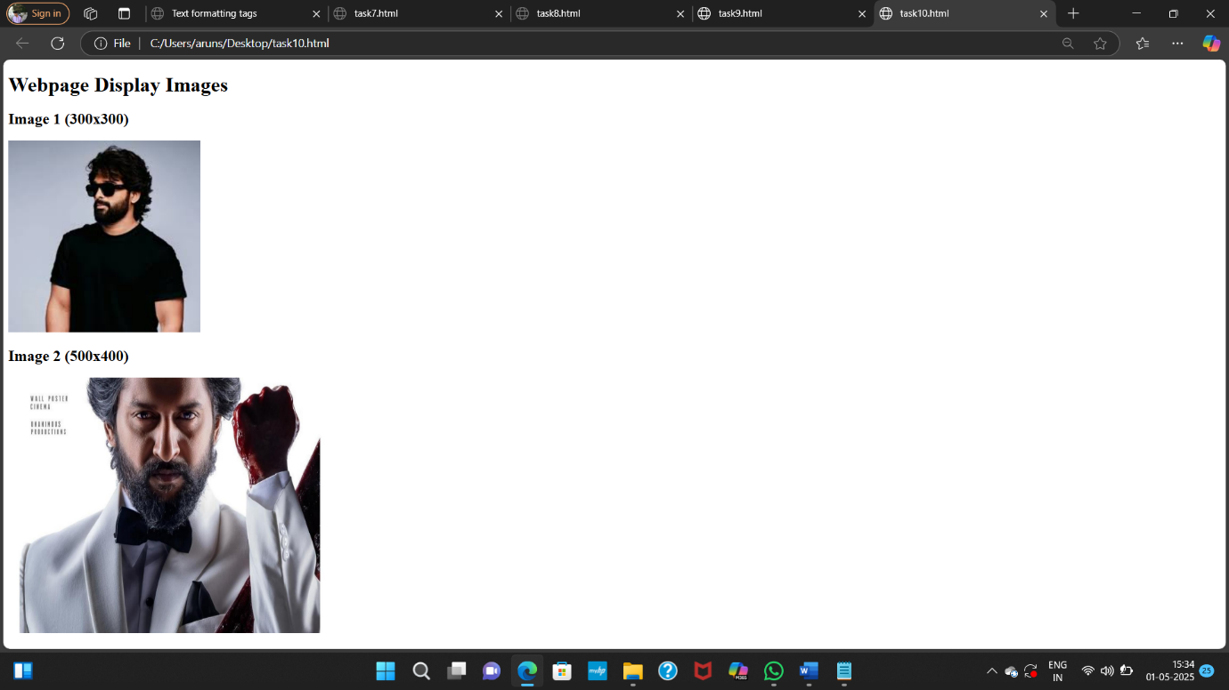

# **TASK 11**

Create a multimedia demo page using HTML.

• Embed a video using the tag with controls, height, and width attributes

• Embed an audio file using the tag with the controls attribute

<!DOCTYPE html>

<html>

<head>

<h1>Multimedia Demo</H>

</head>

<body>

<h2>Video</h2>

<video width="640" height="360" controls>

<source src="C:\Users\aruns\Desktop\ben40.mp4">

Your browser does not support the video tag.

</video>

<h2>Audio</h2>

<audio controls>

<source src="C:\Users\aruns\Downloads\Doraemon.mp3">

Your browser does not support the audio element.

</audio>

</body>

</html>

**OUTPUT:**

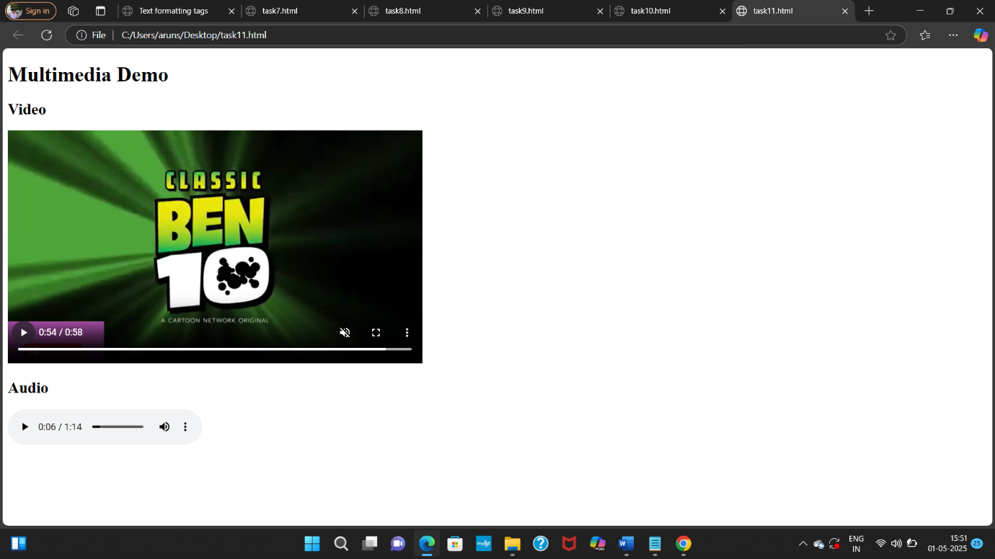

# **TASK 12**

Create a styled sec on using the <div> tag.

The <div> should contain:

• A heading titled "Notification"

• A paragraph with any custom message

• Add a border and padding using inline styles

<!DOCTYPE HTML>

<html>

<head>

<h1>Styled Section</h1>

<h3>Notification</h3>

</head>

<body>

<div style="border: 7px solid #355; padding: 20px; width: 300px;">

<p>morning tiffin 7:30 am to 8:00 am</p>

<p> Evening dinner 9pm to 9:30pm</p>

</div>

</body>

</html>

**OUTPUT:**

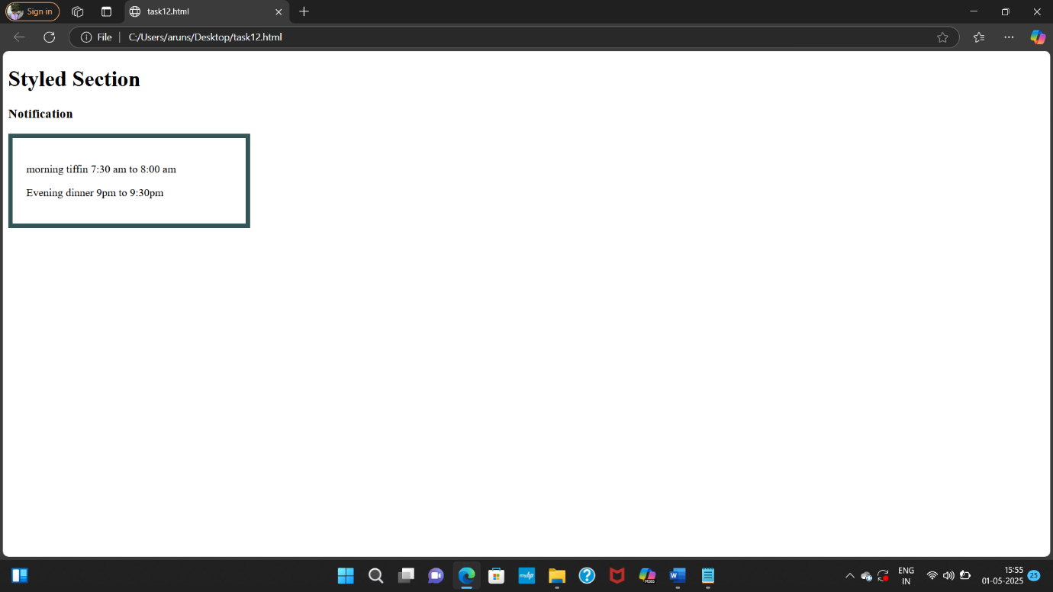

# **TASK 13**

Create a scrolling marquee using the tag.

• Add a scrolling text message from le to right

• Add a marquee with an image scrolling vertically (either up or down)

<!DOCTYPE HTML>

<html>

<head>

<h1>Scrolling Marquee</h1>

</head>

<body>

<marquee behavior="scroll" direction="left"><h3><b>pushpa 3 collected more than 1800 crores!</b></h3></marquee>

<marquee behavior="scroll" direction="up">

<img src="C:\Users\aruns\Desktop\Allu-Arjun-3.webp">

</marquee>

</body>

</html>

**OUTPUT:**

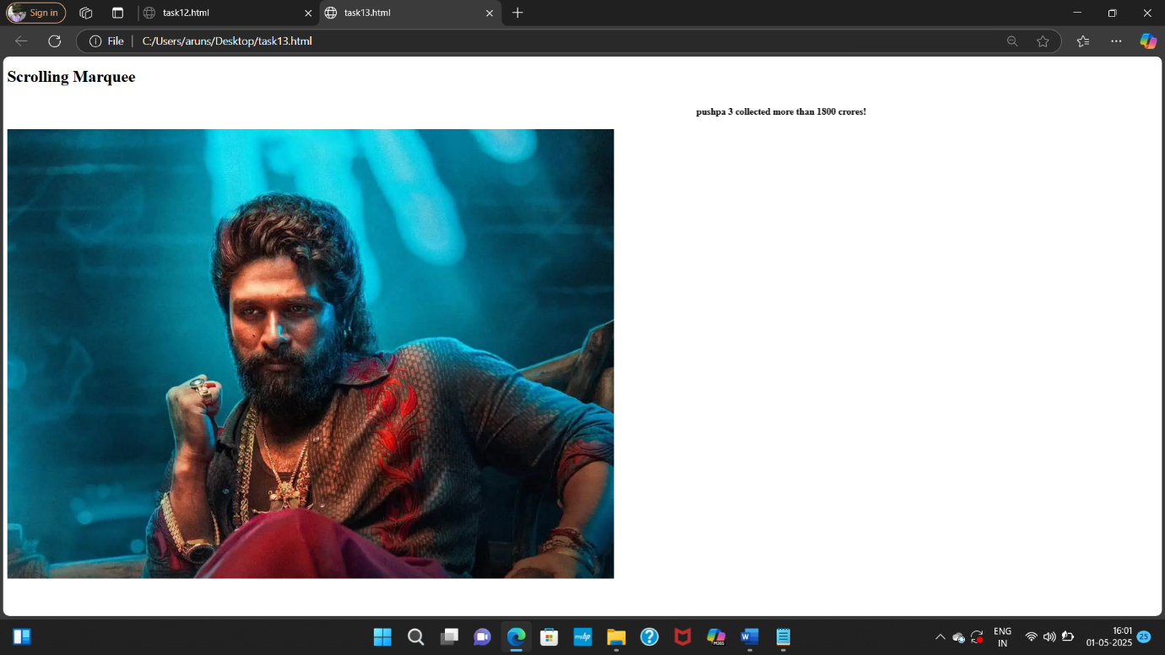

# **TASK 14**

Create a web page with a background image.

• Use the background attribute in the <body>tag

• Add a short paragraph over the background image describing it

<!DOCTYPE HTML>

<html>

<head>

<h1>Webpage with Background image</h1>

</head>

<body background="C:\Users\aruns\Desktop\aaa.jfif">

<p><b><h3>"He is the one of the Tollywood actor"</h3></b> </p>

<P><b><h3>"he is called as stylish star and icon star"</h3></b></P>

<p><b><h3>"he was very hard working person”</h3></b></p>

</body>

</html>

**OUTPUT:**

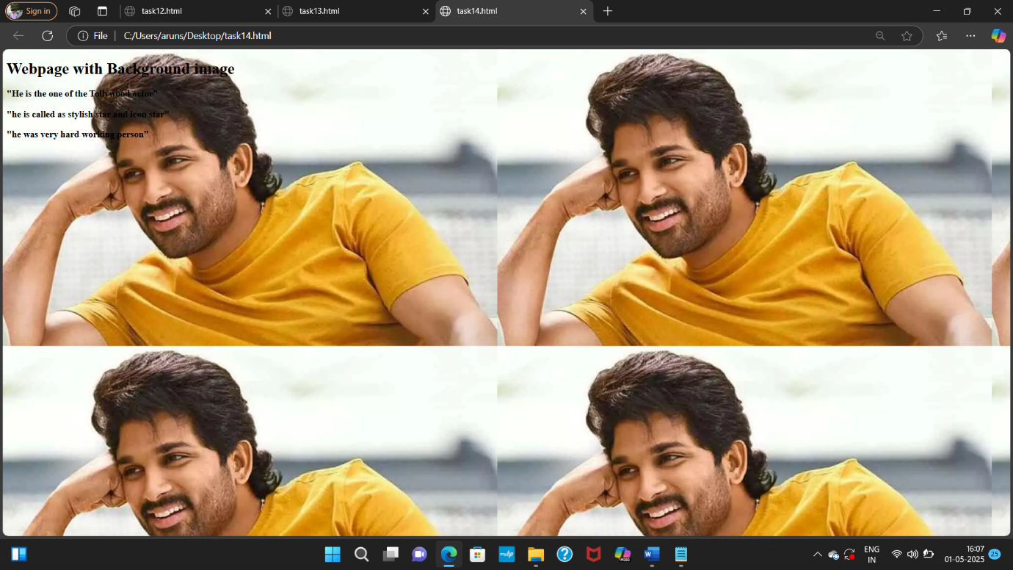

# **TASK 15**

Create a Student Registration Form Design a simple registration form with the following fields:

• Full Name (Text Input)

• Email (Text Input)

• Gender (Radio Buttons: Male, Female, Other)

• Courses Interested (Checkboxes: C, Java, Python, HTML)

• Location (Dropdown: Hyderabad, Vizag, Vijayawada)

• About Yourself (Textarea)

• A link at the bottom that says: “*Already registered? Click here to login*” (Use anchor tag)

<!DOCTYPE html>

<html>

<head>

<title>Student Registration Form</title>

</head>

<body>

<h2>Student Registration Form</h2>

<form>

Name: <input type="text"></input><br><br>

Email: <input type="Email" ></input><br><br>

<div>

<h3>Gender:</h3>

<input type="radio" name="gender" value="male">Male<br>

<input type="radio" name="gender" value="female">female<br>

<input type="radio" name="gender" value="other">Other<br>

</div>

<div>

<h3> Courses Interested:</h3>

<input type="checkbox" name="course" value="C">C<br>

<input type="checkbox" name="course" value="Java">Java<br>

<input type="checkbox" name="course" value="Python">Python<br>

<input type="checkbox" name="course" value="HTML">HTML<br>

</div>

<form>

<h3>Location</h3>

<select name="location">

<option value="Hyderabad">Hyderabad</option>

<option value="Vizag">Vizag</option>

<option value="Vijayawada">Vijayawada</option>

</select>

</form>

<h3>About Yourself</h3>

<textarea name="comments" rows="4" cols="20"></textarea>

<div class="submit-button">

<input type="submit" value="Register">

</div>

<a href="login.html">Already registered? Click here to login</a>

</form>

</body>

</html>

**OUTPUT:**

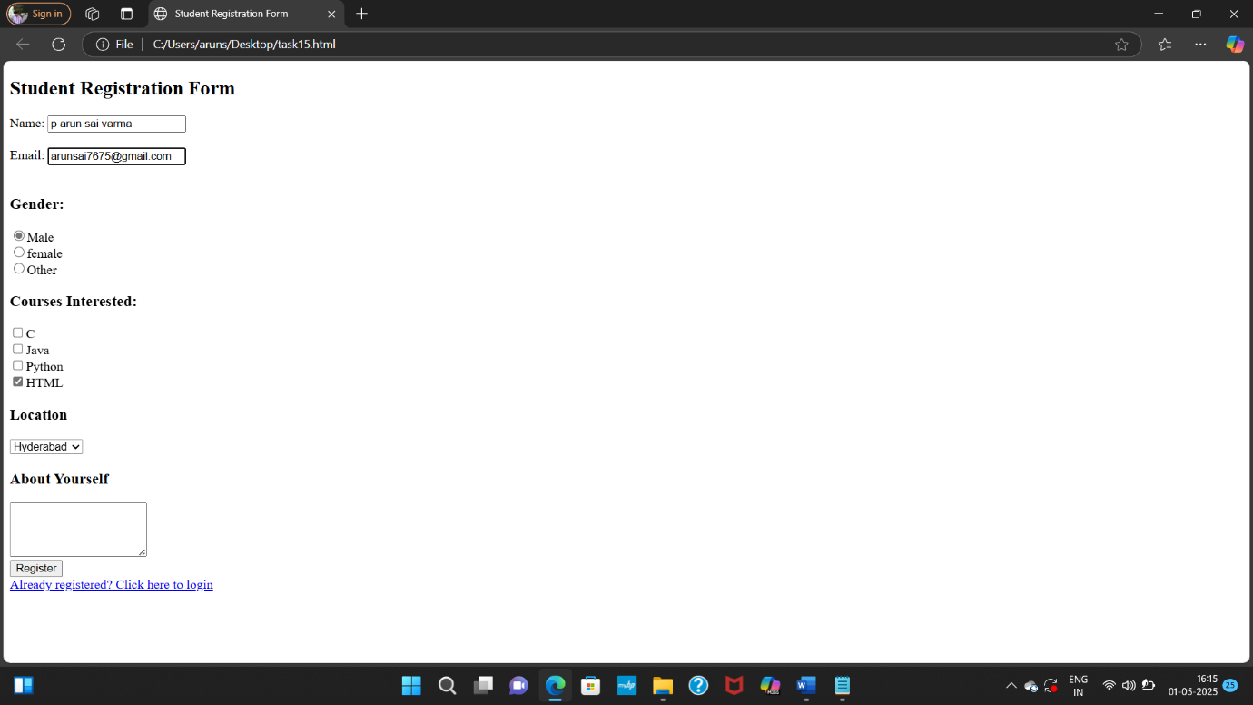

# **TASK 16**

Online Course Enrollment Page

Instructions: Create an online course Enrollment page:

• Title of the page should be centered and prominent

• Add an introductory paragraph

• Include an image related to online learning

• Form inputs:

o Student Name

o Age

o Select your course (at least 4 options)

o Choose your learning mode (Online, Offline, Hybrid)

o Checkbox for: “I agree to the terms and conditions”

o Include a text area for additional comments

<!DOCTYPE html>

<html>

<head>

<title>Teaching skill Course Enrollment</title>

</head>

<body>

<h1>Online Course Enrollment</h1>

<div class="container">

<p> Join the teaching skill coure Enrollment. it is used for the teaching profession and used for the get out from stage fear</p>

<img src="C:\Users\aruns\Downloads\teaching.jpg" alt="Online Learning" width="200" height="200"></img>

<form>

Student Name:<input type="text"><br><br>

Student Age: <input type="number"><br><br>

<h3>Select Your Course</h3>

<select name="Course">

<option value="java">java</option>

<option value="html">html</option>

<option value="Python">Python</option>

<option value="C++">C++</option>

<option value="others">Others</option>

</select>

<h3>Choose Your Learning Mode:</h3>

<select name="mode">

<option value="Online">Online</option>

<option value="Offline">Offline</option>

<option value="Hybrid">Hybrid</option>

</select>

<form>

<input type="checkbox" name="terms" value="I agree to the terms and conditions">I agree to the terms and conditions<br>

</form>

<h3>Additional Comments:</h3>

<textarea name="comments" rows="20" cols="50"></textarea>

<button type="submit">Submit</button>

</form>

</div>

</body>

</html>

**OUTPUT:**

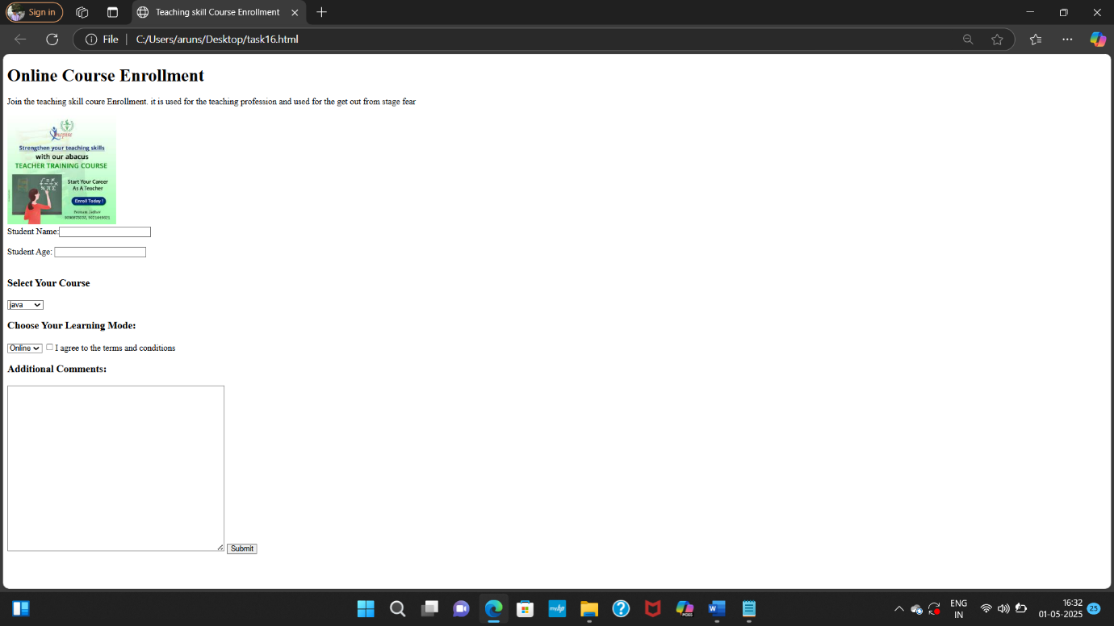

# **TASK 17**

Feedback Form for a Website Instructions:

Create a feedback form that asks users:

• Name

• Email

• How did you hear about the website? (radio options: Google, Social Media, Friend, Others)

• What did you like the most? (checkboxes: UI Design, Speed, Content, Responsiveness)

• Rate us (dropdown with options from 1 to 5 stars)

• Leave a message or comment in a large text area

• Add a button to submit feedback

• Include a link that takes the user back to the homepage

<!DOCTYPE html>

<html>

<head>

<title>Website Feedback Form</title>

</head>

<body>

<h2>Feedback Form</h2>

<form>

Name: <input type="text"><br><br>

Email: <input type="email" ><br><br>

<h4>how the subjects are teaching by the teachers ?</h4>

<form>

<input type="radio" name="source" value="very good">very good</input>

<input type="radio" name="source" value="good">good </input>

<input type="radio" name="source" value="average"> average</input>

<input type="radio" name="source" value="bad"> bad</input>

</form>

<h4>Which subject did u like most?</h4>

<form>

<input type="checkbox" name="like" value="html"> html</input>

<input type="checkbox" name="like" value="phython"> phython</input>

<input type="checkbox" name="like" value="java"> java</input>

<input type="checkbox" name="like" value="c">c</input>

</form>

<h4>Rate us:</h4>

<select name="rating">

<option value="">--Select--</option>

<option value="1">1 Star</option>

<option value="2">2 Stars</option>

<option value="3">3 Stars</option>

<option value="4">4 Stars</option>

<option value="5">5 Stars</option>

</select>

<h4>Leave a message or comment:</h4>

<textarea name="message" rows="20" cols="50"></textarea>

<button type="submit">Submit Feedback</button>

</form>

<a href="http://www.index.html" target="_blank">Back to Homepage</a>

</form>

</body>

</html>

**OUTPUT:**

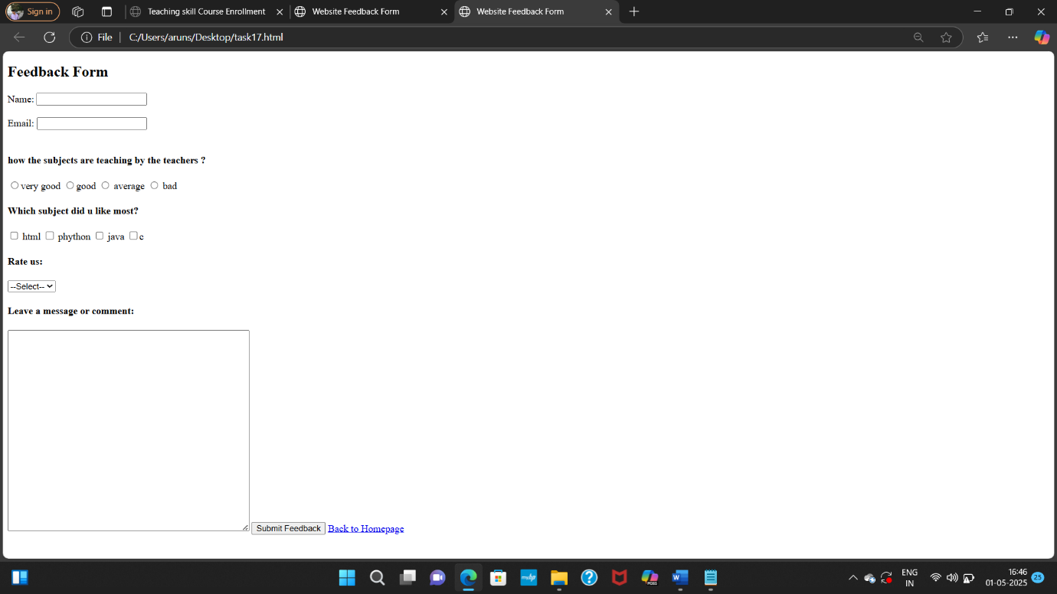

# **TASK 18**

College Event Signup Page Instructions:

Design a form for a college tech fest:

• Title should scroll from right to left

• Include a short welcome message

• Embed a short video or audio about the event

• Provide a table listing different events and their timings

• Registration form should ask:

o Name, Phone Number

o Select your department

o Select the events you want to participate in (at least 4 checkboxes)

o Add a section to share any past experience (text area)

• Add a button to register

• Include a link to view full event details (link to another page)

<!DOCTYPE html>

<html>

<head>

<title>Aditya Degree College Tech Fest 2025</title>

</head>

<body>

<marquee><h2>Aditya Degree College Tech Fest 2025</h2></marquee>

<form>

<h3>Welcome to the Aditya Degree College Tech Fest 2025!</h3>

<video src="C:\Users\aruns\Desktop\sciland.mp4" height="300" width="350" type="video/mp4" controls></video>

<h2>Event Schedule</h2>

<table border="2" padding="50px">

<tr>

<th>Event Name</th>

<th>Timing</th>

</tr>

<tr>

<td>Singing Competition</td>

<td>10:00 AM - 11:00 PM</td>

</tr>

<tr>

<td>SCI-LAND Program </td>

<td>11:30 PM - 12:30 PM</td>

</tr>

<tr>

<td>Project Show Program</td>

<td>1:00 PM - 3:00 PM</td>

</tr>

<tr>

<td>Students Dance Program</td>

<td>3:00 PM - 4:30 PM</td>

</tr>

<tr>

<td>Code deveoping Program</td>

<td>4:30 PM - 5:00 PM</td>

</tr>

</table>

<h2>Register Here</h2>

<form>

Full Name: <input type="text"><br><br>

Phone Number:<input type="number"><br><br>

<h3>Department:</h3>

<select name="Department">

<option value="Computer Science">Computer Science</option>

<option value="Electronics">Electronics</option>

<option value="Air">Air</option>

<option value="Data Science">Data Science</option>

<option value="B.com">B.com</option>

</select>

<h3>Select Events you want to Participate In:</h3>

<form>

<input type="checkbox" name="event1"> Singing Competition</label>

<input type="checkbox" name="event2"> SCI-LAND Program</label>

<input type="checkbox" name="event3"> Project Show Program</label>

<input type="checkbox" name="event4"> Students Dance Program</input>

<input type="checkbox" name="event5"> Code deveoping Program</input>

</form>

<h3>Past Experience (if any):</h3>

<textarea name="experience" rows="20" cols="50"></textarea>

<button type="submit">Register</button>

</form>

<h3>Below the link</h3>

<a href="http://www.event-details.html" target="_blank ">Click here to view full event details</a>

</form>

</body>

</html>

**OUTPUT:**

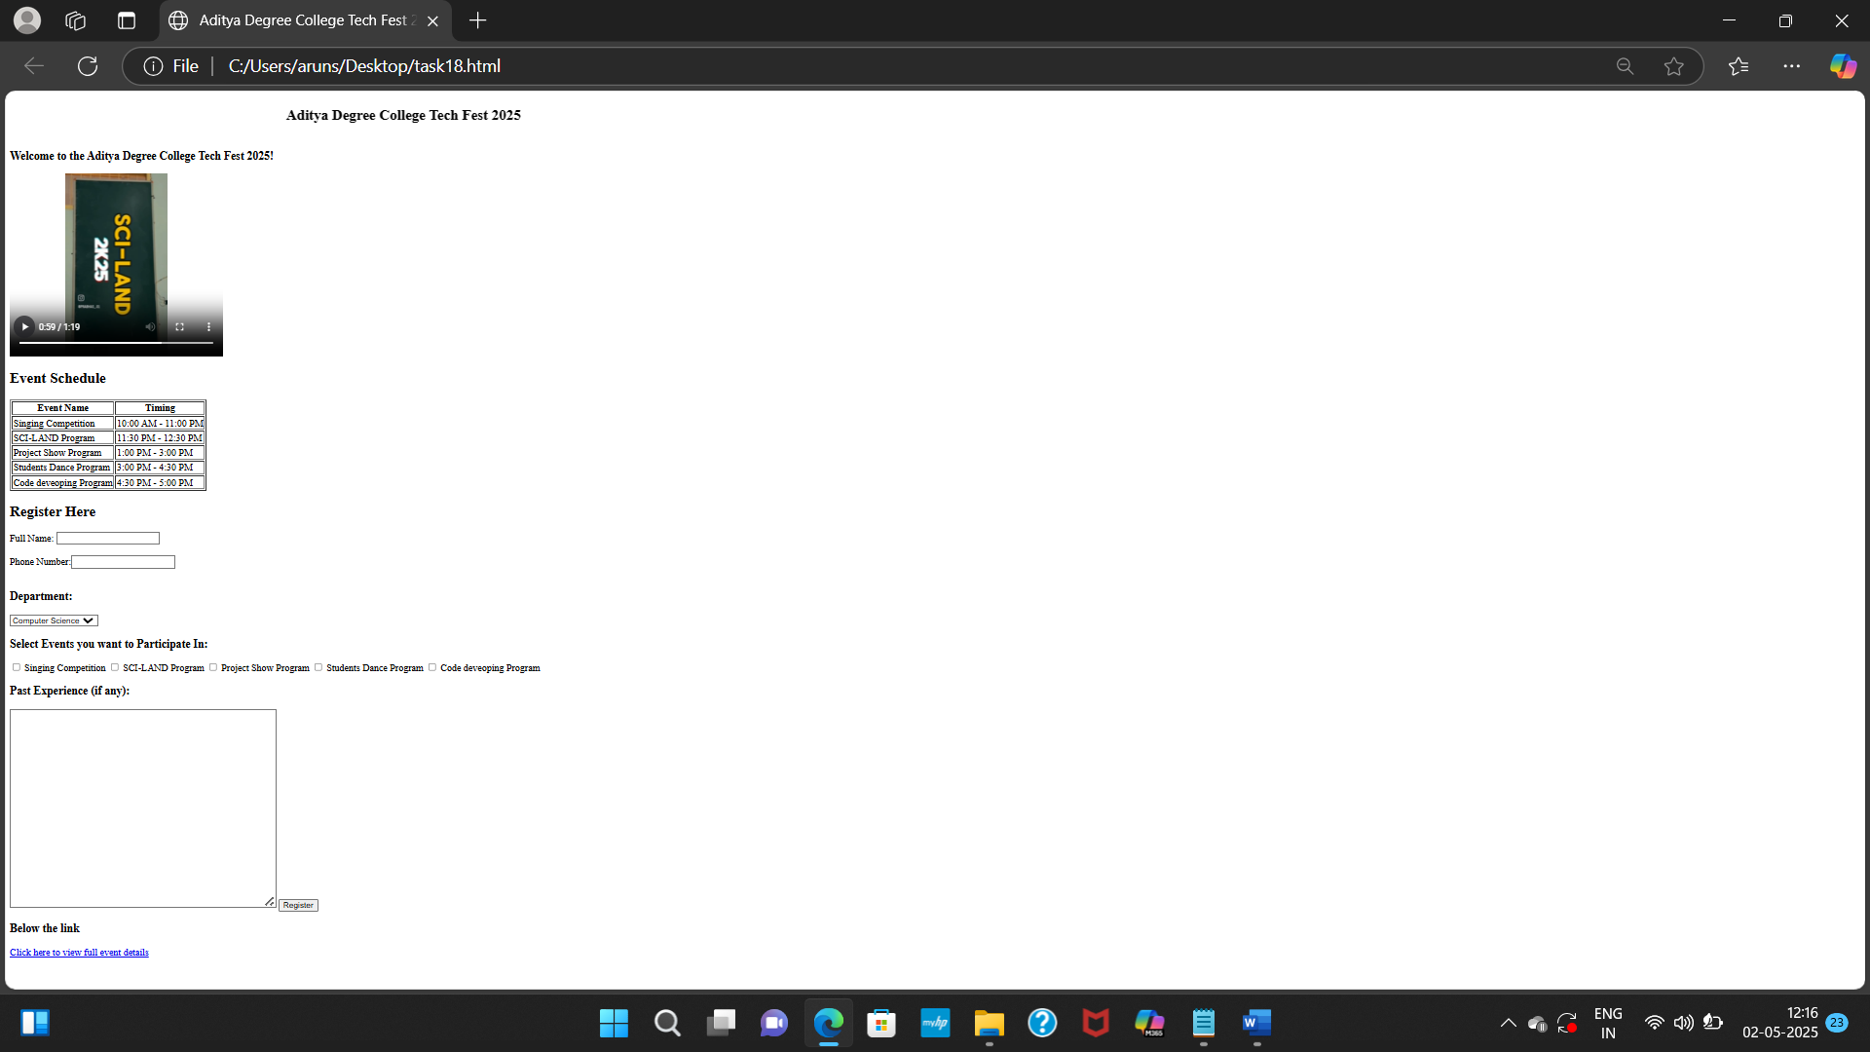

# **TASK 19**

Job Application Form

Instructions: Design a job application form page:

• Use a heading to label the page

• Add a short paragraph describing the company

• Inputs required:

o Applicant Name, Email ID

o Choose preferred job role (Backend, Frontend, Full Stack)

o Skills (checkboxes like HTML, CSS, Python, Java)

o Upload Resume (use a label here for now)

o Add a box where applicant writes about why they want this job

• Add a submission button

• Provide a clickable link: “Visit our company page”

<!DOCTYPE html>

<html>

<head>

<title>Job Application Form</title>

</head>

<body>

<form>

<h1>Job Application Form</h1>

<form>

Applicant Name: <input type="text"><br><br>

Email ID: <input type="email"><br><br>

<h3>Preferred Job Role:</h3>

<select name="role">

<option value="Backend Developer">Backend Developer</option>

<option value="Frontend Developer">Frontend Developer</option>

<option value="Full Stack Developer">Full Stack Developer</option>

</select>

<h3>Skills:</h3>

<form>

<input type="checkbox" name="skills" value="html"> HTML</input>

<input type="checkbox" name="skills" value="c"> C</input>

<input type="checkbox" name="skills" value="html"> Python</input>

<input type="checkbox" name="skills" value="java"> Java</input>

</form>

<label>Upload Resume:</label>

<h3>Why do you want this job?</h3>

<textarea name="about" rows="5" cols="60"></textarea>

<button type="submit">Submission</button>

</form>

<h3>Below the company link</h3>

<a class="company-link" href="https://www.techspark.com" target="_blank">Visit our company page</a>

</div>

</body>

</html>

**OUTPUT:**

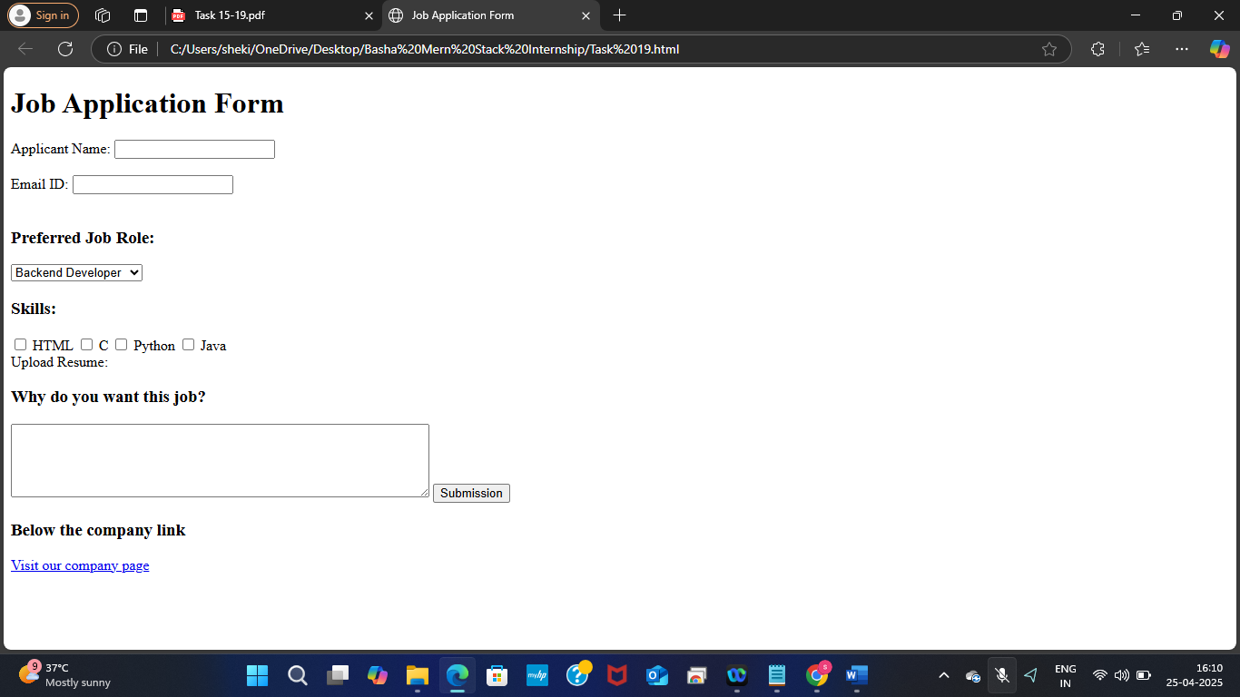

Task-20

**Create a personal website homepage that includes:**

**A top section with your name and links to different pages (like Home, Projects, and Contact).**

**A short paragraph describing your background.**

**An image of yourself with a short description below it.**

**Source Code:**

<!DOCTYPE html>

<html>

<head>

<title>My Personal Website</title>

</head>

<body>

<header>

<h1>p.Arun sai varma</h1>

<nav>

<a href="#">home</a> |

<a href="#">Projects</a> |

<a href="#">Contact</a>

</nav>

</header>

<div>

<article>

<h2> My Background</h2>

<p>

i am beginner of the <ins>coding and web development</ins> , "i have a problem solving Skills and Communication skills".

</p>

</article>

<section>

<img src= "C:\Users\aruns\Documents\Picsart_25-04-20_21-45-58-815.jpg" width="200" height="250"></img>

<p>my name is P arun sai varma . I am an full stack developer</p>

</section>

</div>

</body>

</html>

**Output:**

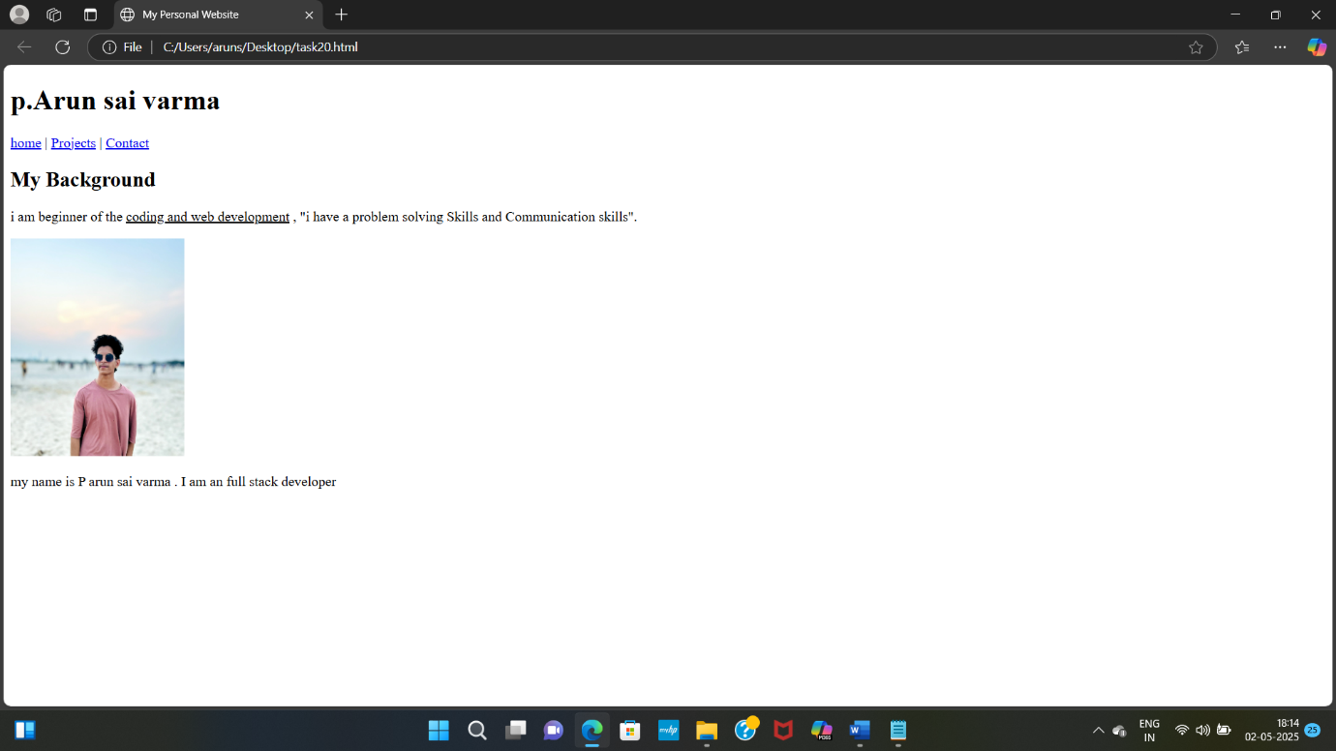

**Task-21**

**Design a layout with two vertical panels:The left panel should show any website of your choice.The right panel should show Wikipedia.Remove the divider between the two panels.**

**Source Code:**

<!DOCTYPE html>

<html>

<head>

<title>two vertical paneles</title>

</head>

<frameset cols="50%,50%">

<frame src="C:\Users\aruns\Desktop\Allu-Arjun-3.webp" noresize>

<frame src="C:\Users\aruns\Desktop\HIT 3.jpg" >

</frameset>

</html>

**Output:**

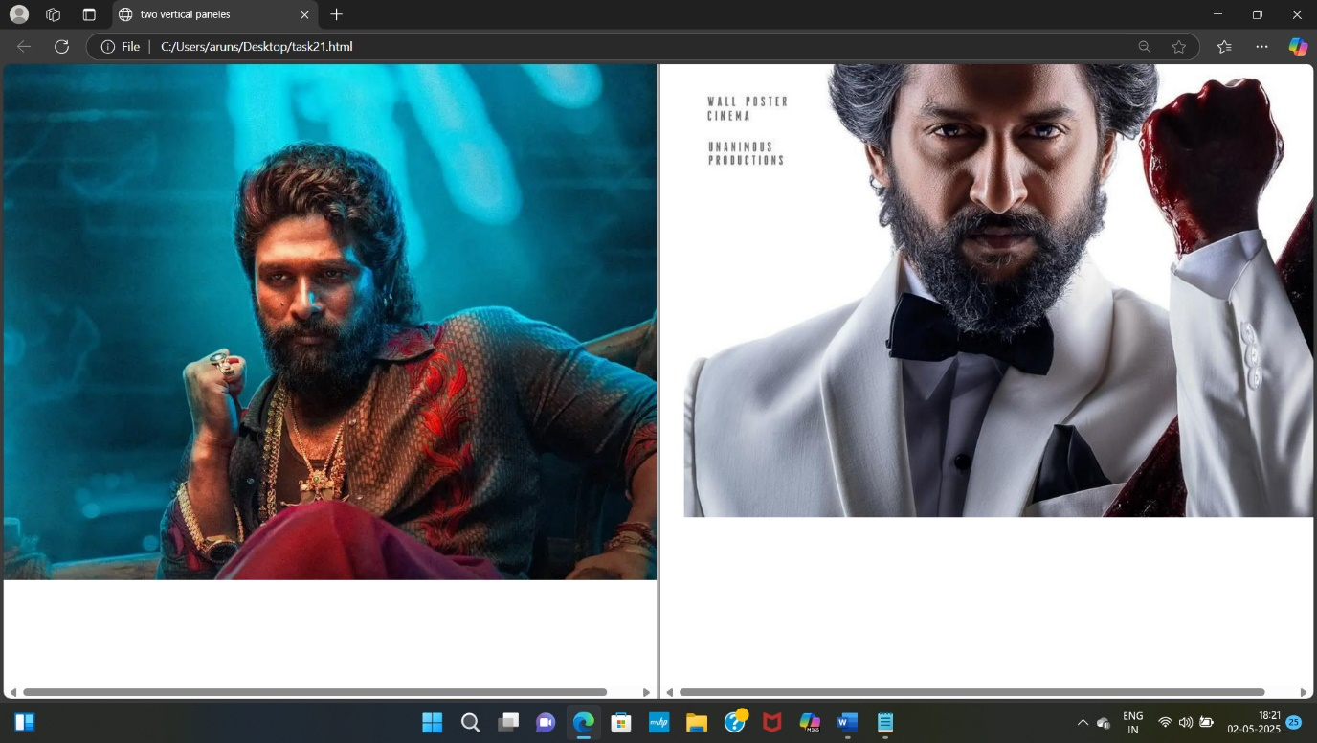

**Task-22**

**Build a form for event registration where:**

**Users can enter their full name, email, and phone number.**

**They can choose one gender option and select multiple interests (like music, sports,**

**art).**

**Users should be able to pick their city from a dropdown.**

**A comments box should be available for extra details.**

**Add buttons to submit, reset, and trigger a confirmation alert**

**Source Code:**

<!DOCTYPE html>

<html>

<head>

<title>Event Registration Form</title>

</head>

<body>

<h2>Event Registration Form</h2>

<form>

Name: <input type="text"></input><br><br>

ph no. : <input type="number"></input><br><br>

Email: <input type="Email" ></input><br><br>

<div>

<h3>Gender:</h3>

<input type="radio" name="gender" value="male">Male<br>

<input type="radio" name="gender" value="female">female<br>

<input type="radio" name="gender" value="other">Other<br>

</div>

<div>

<h3> Multiple Interests:</h3>

<input type="checkbox" name="course" value="music">Music<br>

<input type="checkbox" name="course" value="Sports">Sports<br>

<input type="checkbox" name="course" value="Art">Art<br>

</div>

<form>

<h3>Location</h3>

<select name="location">

<option value="kerala">kerala</option>

<option value="goa">goa</option>

<option value="Vijayawada">Vijayawada</option>

</select>

</form>

<h3>Comment box</h3>

<textarea name="comments" rows="4" cols="20"></textarea>

<div class="submit-button">

<input type="submit" value="Register">

<input type="submit" value="submit">

</div>

<button onclick="showConfirmation()">Trigger</button>

<script>

function showConfirmation() {

const result = confirm("Are you sure you want to proceed?");

if (result) {

alert("Submitted your degtails Confirmed!");

} else {

alert("Cancelled!");

}

}

</script>

</form>

</body>

</html>

**Output:**

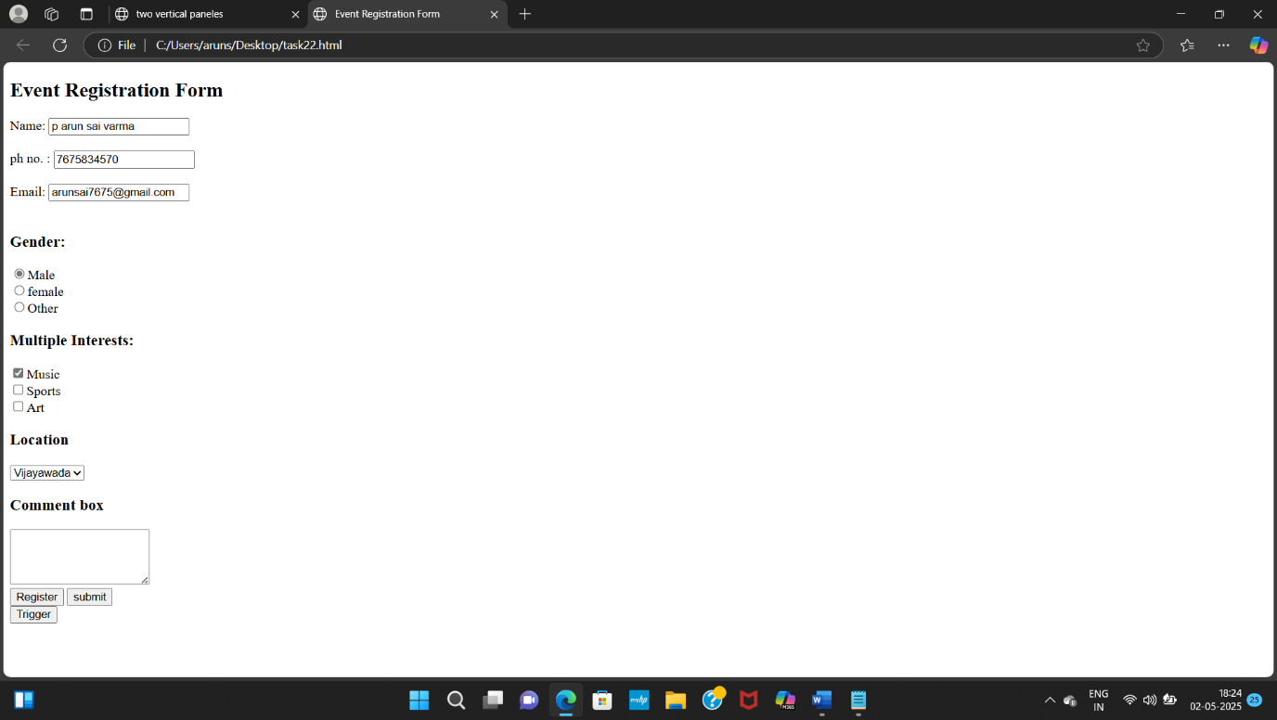

**Task-23**

**Create a single webpage layout that includes:**

**A section displaying today’s news headline and summary.**

**Another section beside it displaying tips or advertisements.**

**A bottom section with author info, the year, and an email to contact**

**Source Code:**

<!DOCTYPE html>

<html>

<head>

<title>Single Webpage</title>

</head>

<body>

<form>

<section class="news">

<h2>Today's Headline</h2>

<p>Prime Minister Narendra Modi formally inaugurated the Vizhinjam seaport in Kerala's capital city of Thiruvananthapuram on Friday.</p>

</section>

<section class="tips & ads">

<h2>Tips & Ads</h2>

<ul>

<li>Tip: Narendra modi done an great job.</li>

<li>Ad: Check out all the details of this news in site of the Indian express</li>

</ul>

</section>

<footer>

<p>Copyright © 2025 in Indian express website</p>

<p> Contact :< https://indianexpress.com/</a></p>

</footer>

</form>

</body>

</html>

**Output:**

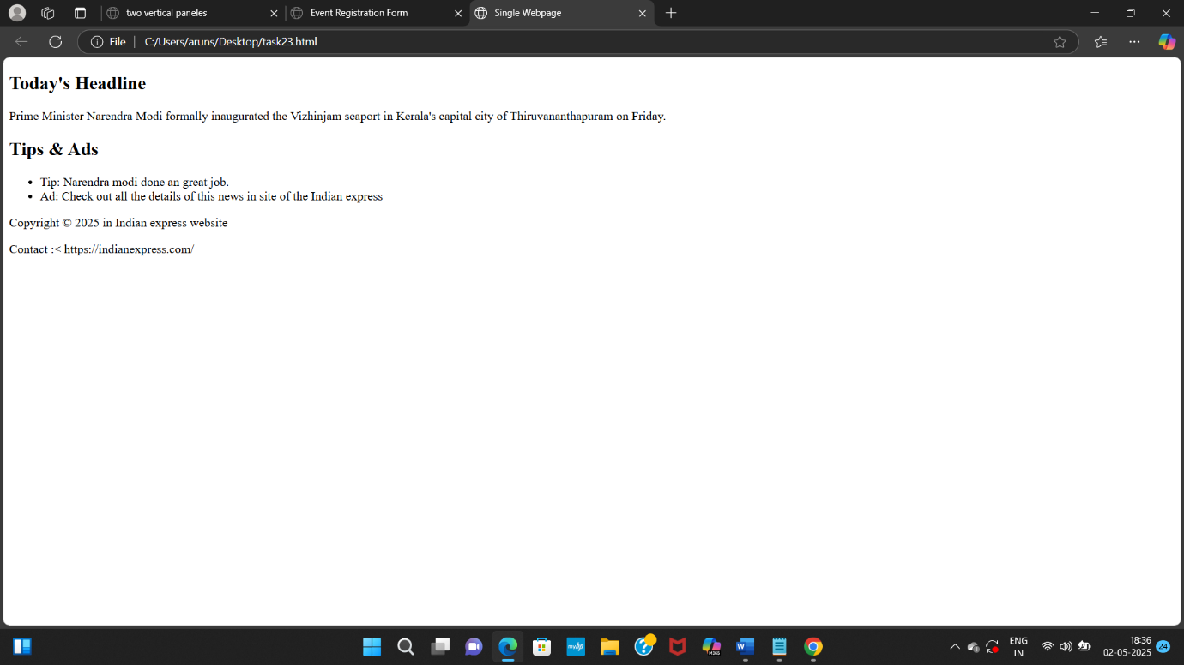

Task 24

**Build a payment selection form that groups options like UPI, Credit Card, and Cash on Delivery under one box.**

**Add a label above this sectiondescribing it as a "Payment Method".**

**Each option should be selectable by clicking a circle.**

**Source code:**

**<!DOCTYPE html>**

**<html>**

**<head><title>Payment Selection</title></head>**

**<body>**

**<form>**

**<fieldset>**

**<h2>Payment Method</h2>**

**<label>**

**<input type="radio" name="pay" value="upi">UPI<br>**

**<input type="radio" name="pay" value="credit-card">Credit Card<br>**

**<input type="radio" name="pay" value="cod">Cash on Delivery<br>**

**</label>**

**</fieldset>**

**</form>**

**</body>**

**</html>**

**Output:**

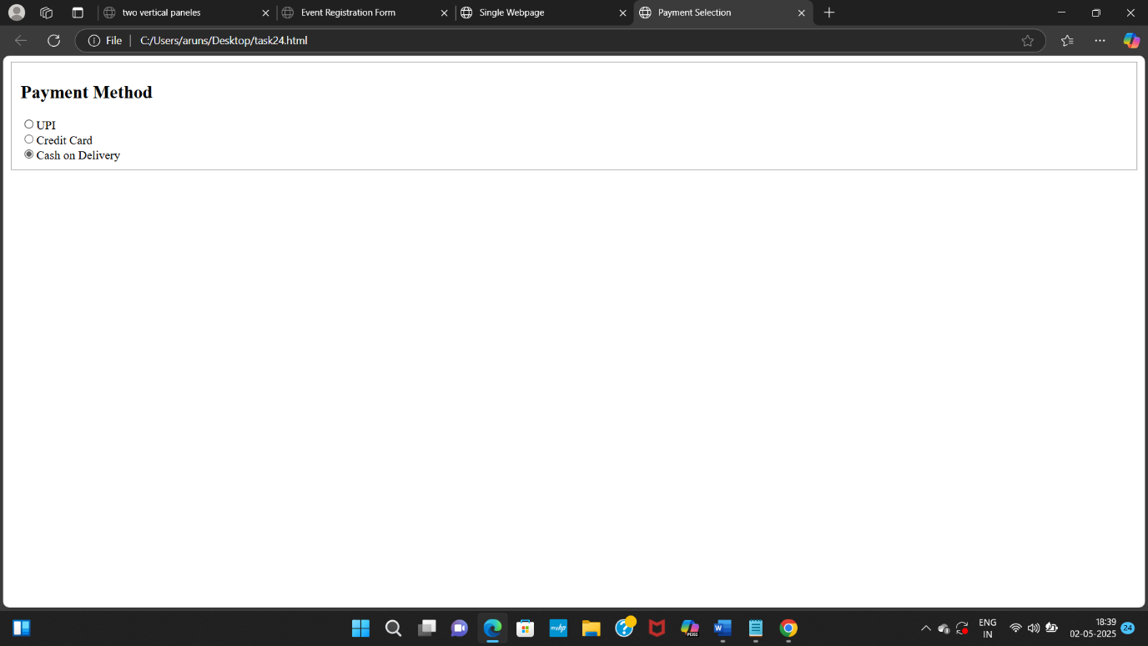

**Task 25**

**Display a product offer where:**

**The original price is shown with a line through it.**

**The discounted price is highlighted.**

**A note says that new features are included (highlighted with underlining).**

**Source code:**

**<!DOCTYPE html>**

**<html>**

**<head>**

**<title>Product Offer</title>**

**</head>**

**<body>**

**<fieldset>**

**<h2>Product Offer</h2>**

**<p> The tv price is 49999</del></p>**

**<p> Now its discounted price is <mark>$35999</mark> only</p>**

**<h4>Note:</h4>**

**<p><u>There is no extra cost for new model pieces</u></p>**

**</fieldset>**

**</body>**

**</html>**

**Output:**

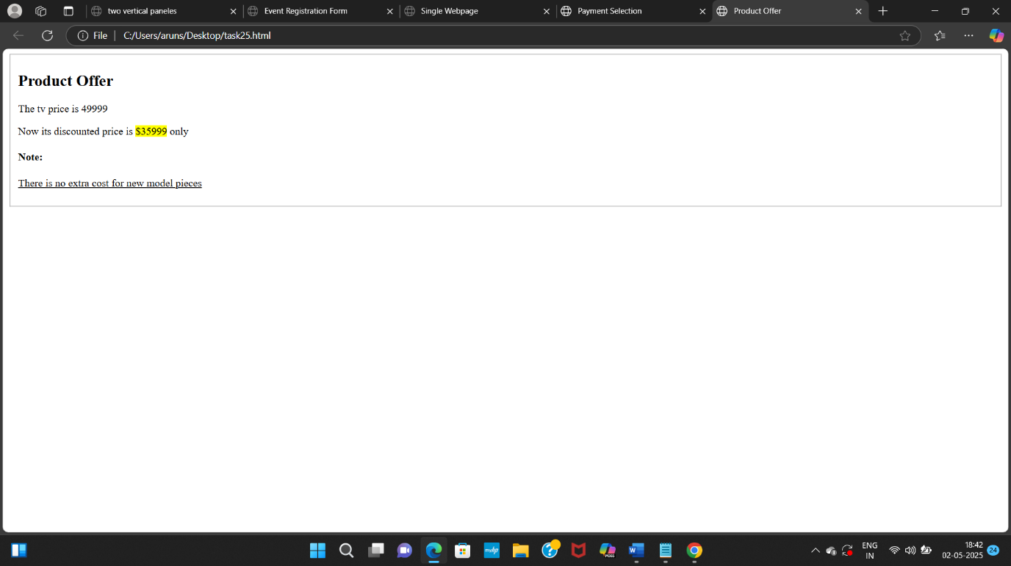

**Task-26**

**Design a layout for a blog with:**

**A title and navigation menu at the top.**

**A main article about a trip you took.**

**A sidebar with travel tips**

**A footer with your contact email and rights notice.**

**Source Code:**

<!DOCTYPE html>

<html>

<head><title>Blog Example</title>

</head>

<body>

<header>

<h1>My movie review vlog</h1> <nav>

<a href="#home">Home</a> |

<a href="#destinations">Destinations</a> |

<a href="#contact">Contact</a> |

<a href="#Gallery">Gallery</a>

</nav>

</header>

<div>

<article>

<h2>hit 3 movie review</h2>

<p>Nani acting was just mind blowing specially director want to express arjun sarkaar character and it came out superb It was a good film.</p>

</article>

<section>

<h3>movie details</h3>

<ul>

<li>Nani performance was out standing.</li>

<li>the screen presentation was good.</li>

<li>story telling also good.</li>

</ul>

</section>

</div>

<footer>

<p>Copyright © 2025 All rights hit3 reserved</p>

<p>Contact :<a href="mailto:arunsai99@gmail.com">arunsai99@gmail.com</a> </p>

</footer>

</body>

</html>

**Output:**

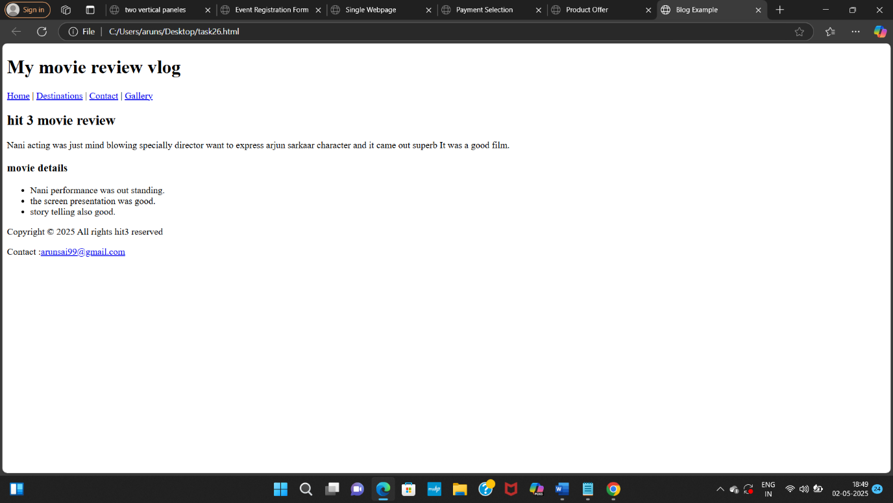

**Task 27**

**Simulate a science or math article:**

**Mention the chemical formula for water.**

**Show the square of a number in proper format.**

**Mention a quote from a famous scientist**

**Source code:**

**<!DOCTYPE html>**

**<html>**

**<head>**

**<title>Science or math article</title>**

**</head>**

**<body>**

**<h1>Science and Math article</h1>**

**<p>lithium oxide chemical formula is li<sub>2</sub>o<sub></p>**

**<p> This is the square of the number (23)<sup>2</sup>=529 </p>**

**<p><b>Famous Scientist</b>: <u>A.P.J.Abdul kalam</u></p>**

* **<p>Never stop fighting until you arrive at your destined place - that is, the unique you..</p>**

**</body>**

**</html>**

**Output:**

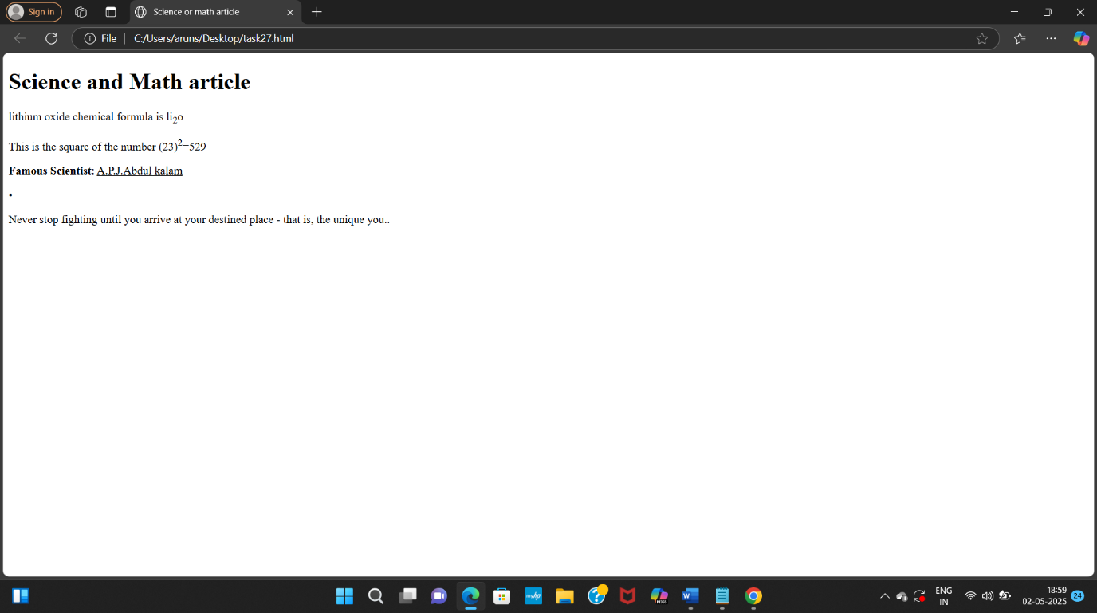

Task 28

**Create a support form:**

**Group address and contact fields inside a boxed section.**

**Ask users to enter full name, mobile number, and address.**

**Add a heading to this section like “Delivery Info”**

**Source code:**

**<!DOCTYPE html>**

**<html>**

**<head>**

**<title>Support Form</title>**

**</head>**

**<body>**

**<fieldset>**

**<h2>Details for ordering an product</h2>**

**<form>**

**Full Name: <input type="text"></input><br><br>**

**mobile no.: <input type="text"></input><br><br>**

**Address : <textarea id="address" name="address" rows="4" required></textarea><br><br>**

**</form>**

**</fieldset>**

**</body>**

**</html>**

**Output:**

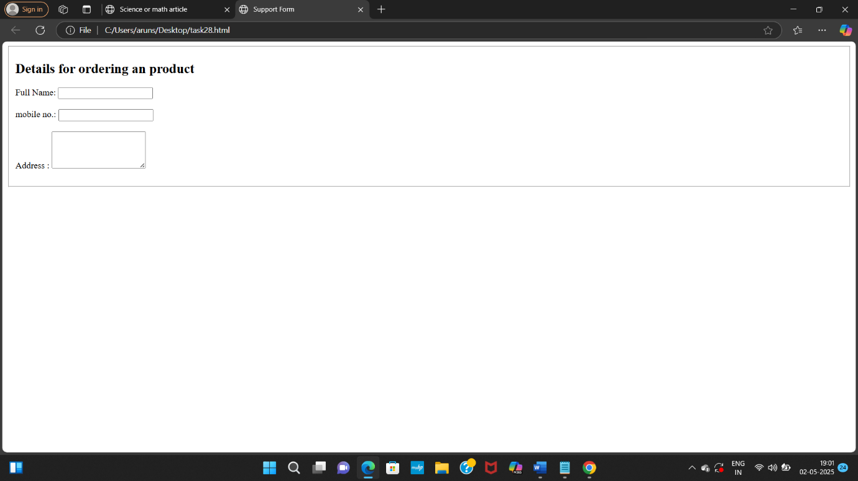

Task-29

**Develop a mini photo gallery:**

**Include one or two images from your favorite place.**

**Each image should include a small descriptive caption.**

**Arrange the images below a page title.**

**Source Code:**

<!DOCTYPE html>

<html>

<head>

<title>My Travel Gallery</title>

</head>

<body>

<h1>My Favorite Places</h1>

<div>

<form>

<img src="C:\Users\aruns\Desktop\et.webp" alt="City" width="300px" height="300">

<p>The Eiffel Tower offers a variety of immersive experiences for visitors, including panoramic views, historical insights, and virtual reality tours. </p>

</form>

<form>

<img src="C:\Users\aruns\Desktop\manali" width="300px" height="300px">

<p>Manali is often referred to as the "Valley of the Gods" and is nestled in the majestic Himalayas, showcasing the unparalleled creativity of nature.</p>

</form>

</div>

</body>

</html>

**Output:**

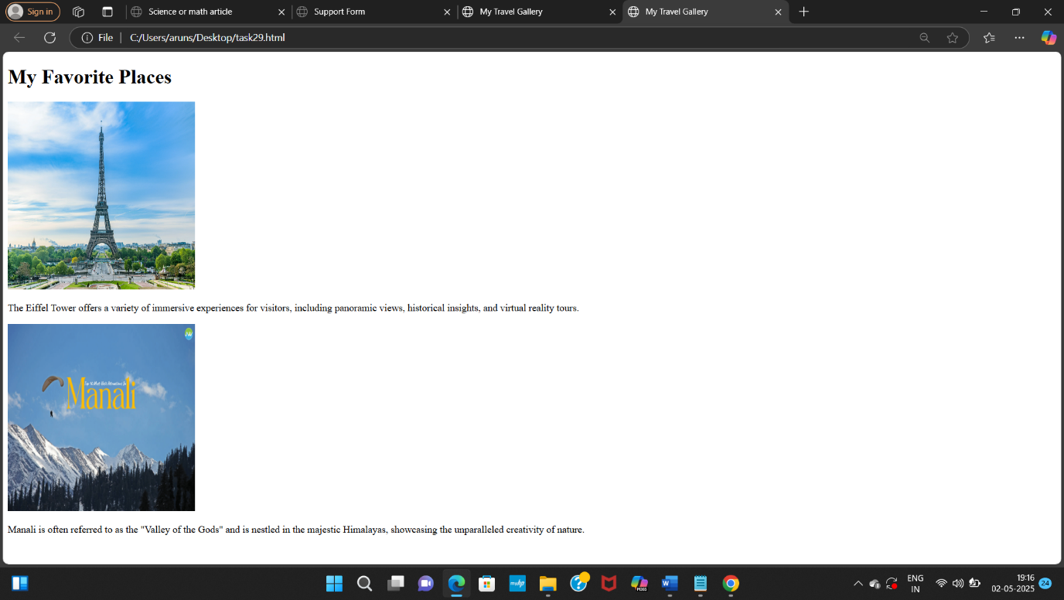

**TASK 30**

**30 Create a Layout Using Universal and Type Selectors**

**Instructions:**

**\*Use the universal selector (*) to apply base styles like box-sizing, margin, and**

**padding.**

**\* Apply a common font-family and line-height to all elements.**

**\*Use type selectors (h1, p, ul, etc.) to style headings, paragraphs, and lists.**

**\* Include a header with a title, a content section with paragraphs, and a footer.**

**Source code:**

<!DOCTYPE html>

<html>

<head>

<title>Simple Layout</title>

<style>

/* Universal selector for base styles */

* {

box-sizing: border-box;

margin: 0;

padding: 10;

font-family: Arial, sans-serif;

line-height: 1.6;

}

/* Type selectors */

body {

background-color: skyblue;

color: black;

padding: 20px;

}

header {

background-color: green;

color: red;

padding: 20px;

text-align: center;

}

h1 {

font-size: 2em;

}

main {

margin-top: 20px;

}

p {

margin-bottom: 10px;

}

ul {

margin-left: 20px;

}

footer {

background-color: lightgrey;

padding: 10px;

text-align: center;

margin-top: 20px;

}

</style>

</head>

<body>

<header>

<h1> Layout</h1>

</header>

<main>

<p>This layout uses the universal selector.</p>

<p>Type selectors are used for styling.</p>

<ul>

<li>h1</li>

<li>p</li>

<li>ul</li>

</ul>

</main>

<footer>

<p>Footer</p>

</footer>

</body>

</html>

**Output:**

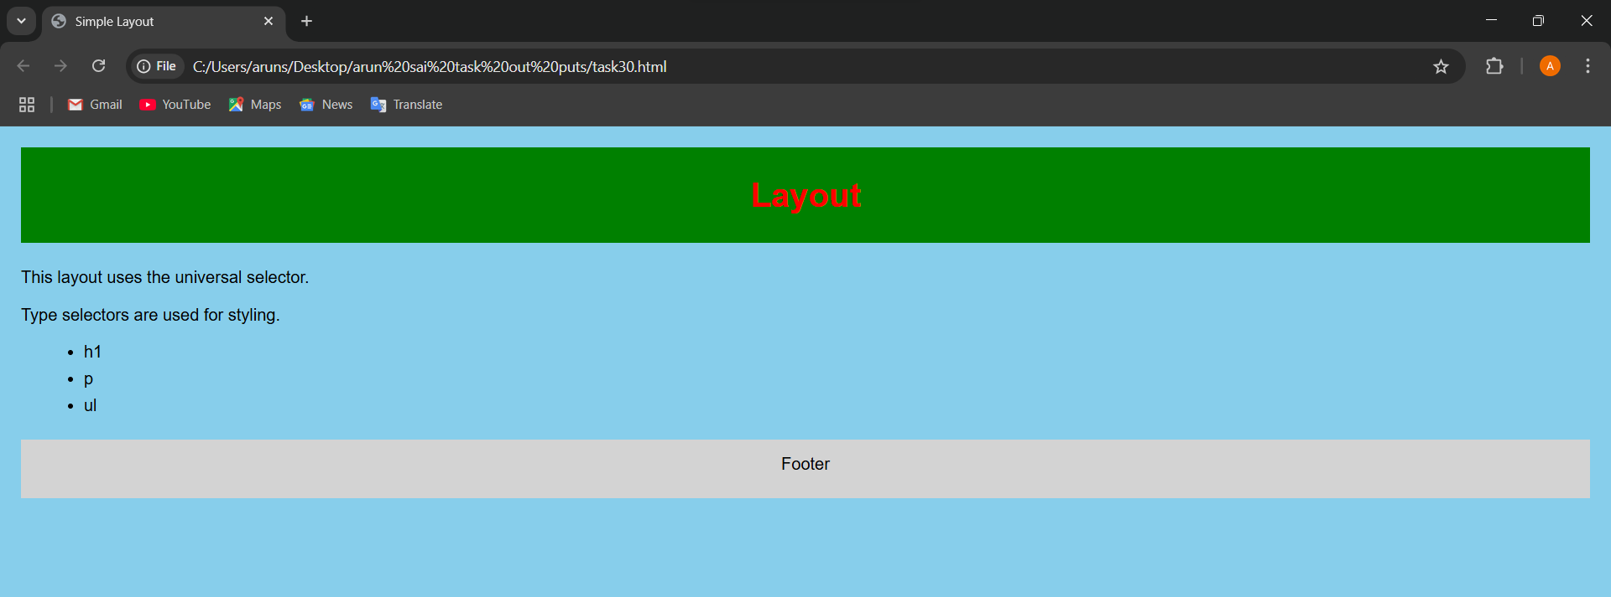

**Task 31**

**31 Create a Login Form Using the <fieldset> and <legend> Tags**

**Instructions:**

**\* Create a form with username and password input fields.**

**\* Wrap the form controls inside a <fieldset>**

**\* Add a <legend> with the label "Login Details".**

**\*Style the legend to be bold and slightly larger for emphasis.**

**Source code:**

<!DOCTYPE html>

<html>

<head>

<title>Login Form</title>

</head>

<body>

<style>

fieldset {

width: 250px;

margin: 40px auto;

padding: 14px;

}

legend {

font-weight: bold;

font-size: 15px;

}

</style>

<form>

<fieldset>

<legend>Login Details</legend>

Name: <input type="text"></input><br><br>

Password: <input type="text"></input><br><br>

<input type="submit" value="Login">

</fieldset>

</form>

</body>

</html>

**Output:**

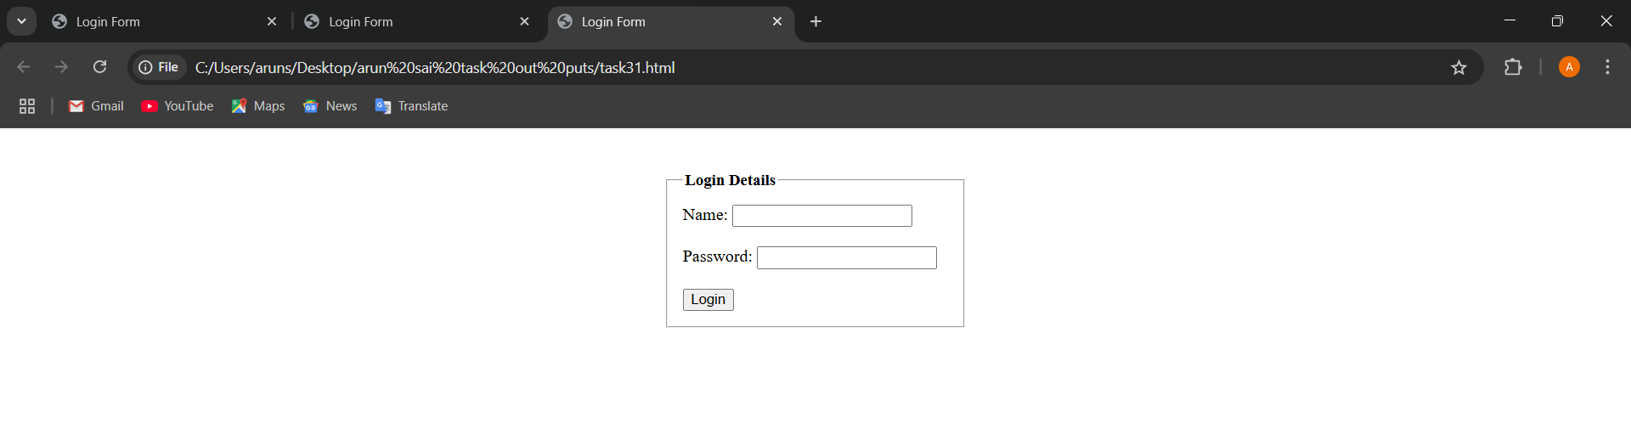

**TASK 32**

**32 Style Elements Using Class and ID Selectors**

**Instructions:**

**\*Create a webpage with a title and two or more paragraphs.**

**\* Assign a class (e.g., .highlight) to one or more paragraphs to apply the same style.**

**\* Assign a unique ID (e.g., #main-title) to the heading. Use CSS to:**

**o Style the ID with a specific font color and alignment. o Style the class with a background color and padding.**

**Source code:**

<!DOCTYPE html>

<html>

<head>

<style>

#main-title {

color: green;

text-align: center;

}

.highlight {

background-color: lightblue;

padding: 10px;

}

</style>

</head>

<body>

<h1 id="main-title">India Today</h1>

<p class="highlight">there was conducting a yoga day in the vizag.</p>

<p>the all paticipaints are getting the Guinness record certificates .</p>

<p></p>the three lakh of members were paticipiated.</p>

</body>

</html>

**Output:**

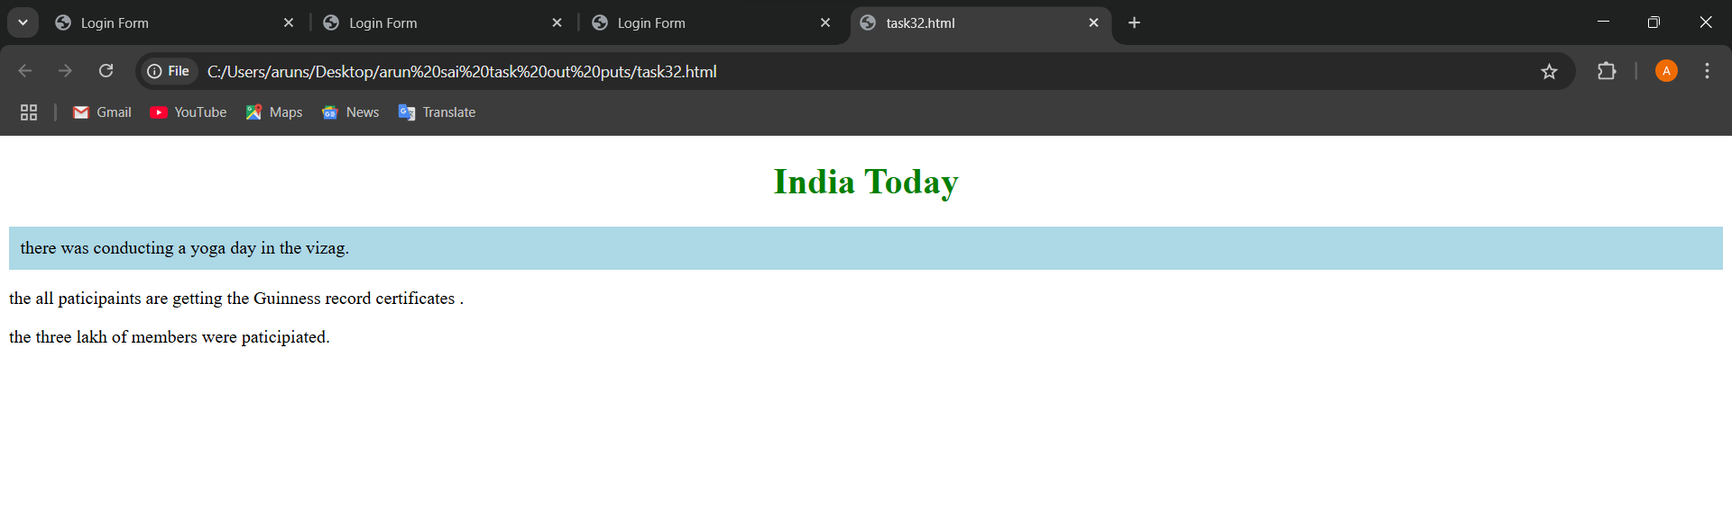

**TASK 33**

**33 Design a timetable using css**

**Source code:**

**<**!DOCTYPE html>

<html>

<head>

<style>

table {

border: 1px solid black;

border-collapse: collapse;

width: 60%;

}

h2{

text-align: center;

margin-bottom: 20px;}

td {

border: 1px solid black;

padding: 12px;

text-align: center;}

th {

background-color: green;

color: black;

border: 1px solid black;

padding: 12px;

text-align: center

}

</style>

</head>

<body>

<h2>I Standard Timetable</h2>

<table>

<tr>

<th>Day</th>

<th>8:45-9 AM</th>

<th>9-10 AM</th>

<th>10-11 AM</th>

<th>11-12 PM</th>

</tr>

<tr>

<td>Monday</td>

<td>Prayer</td>

<td>English</td>

<td>Maths</td>

<td>Crafts</td>

</tr>

<tr>

<td>Tuesday</td>

<td>Prayer</td>

<td>Telugu</td>

<td>Social</td>

<td>Music</td>

</tr>

<tr>

<td>Wednesday</td>

<td>Prayer</td>

<td>E.V.S</td>

<td>Hindi</td>

<td>Drawing</td>

</tr>

<tr>

<td>Thursday</td>

<td>Prayer</td>

<td>Maths</td>

<td>G.K</td>

<td>Quiz</td>

</tr>

<tr>

<td>Friday</td>

<td>Prayer</td>

<td>Social</td>

<td>E.V.S</td>

<td>Games</td>

</tr>

<tr>

<td>Saturday</td>

<td>Prayer</td>

<td>Telugu</td>

<td>English</td>

<td>C.T</td>

</table>

</body>

</html>

**Output:**

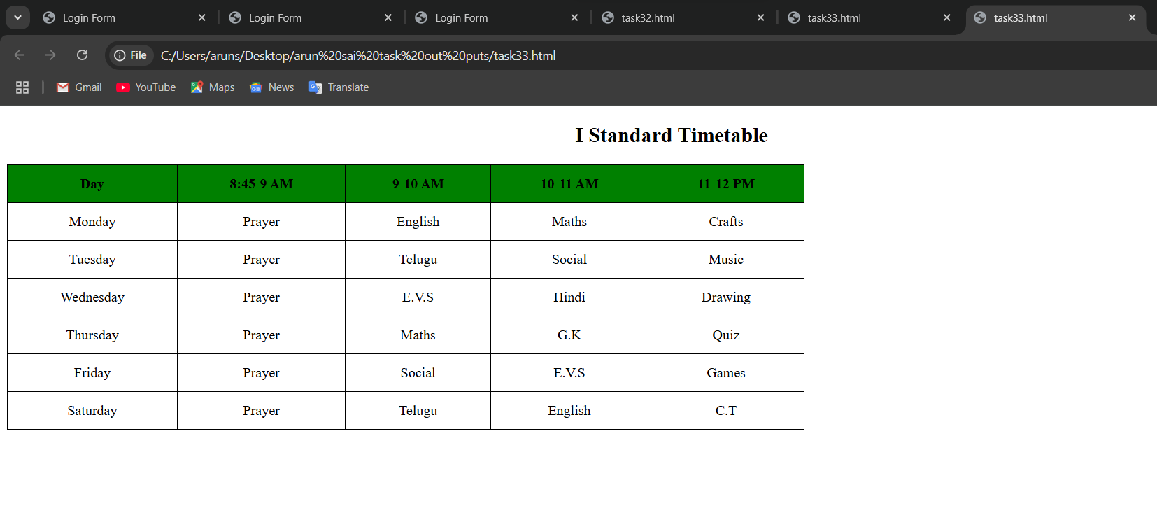

**TASK 34**

**34 Create a webpage where you style multiple elements using a class selector.**

**\* Apply the following styles:**

**Set the text color to blue and font size to 18px for all elements that share the**

**same class.**

**Source code:**

<!DOCTYPE html>

<html>

<head>

<title>Class Selector</title>

<style>

.highlight {

color: red;

font-size: 18px;

}

</style>

</head>

<body>

<h1>India Today</h1>

<p class="highlight">India draws a tough new normal for dealing with a recalcitrant Pakistan over sponsoring terror.</p>

<div class="highlight">The Supreme Court opens up on judges'assets and appointments in an unprecedented act of transparency and self-scrutiny.</div>

</body>

</html>

**Output:**

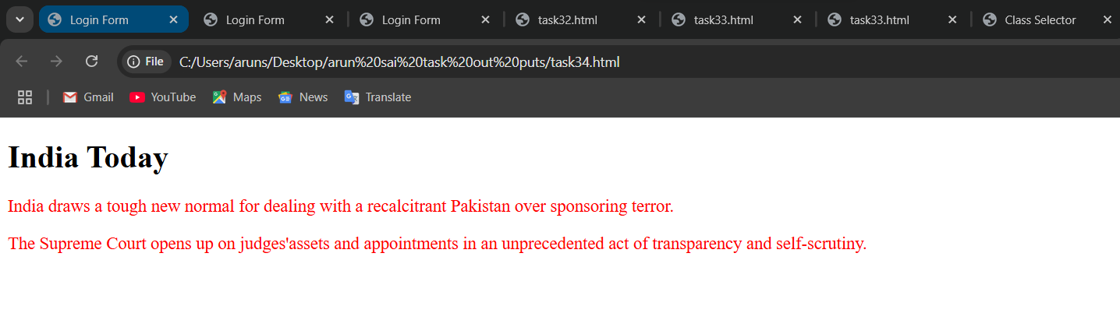

**TASK 35**

**35 Define a class selector that changes the background color of the elements to lightgray.**

**•* Additionally, set the font-family to Arial and the padding to 10px.**

**• *Apply this class to at least two elements in the webpage**

**Source code:**

<!DOCTYPE html>

<html>

<head>

<title>Background Style</title>

<style>

.box-style {

background-color: brown;

font-family: Arial;

padding: 10px;

}

</style>

</head>

<body>

<div class="box-style">Hello Everyone!!</div>

<p class="box-style">This is a task in CSS.</p>

</body>

</html>

**Output:**

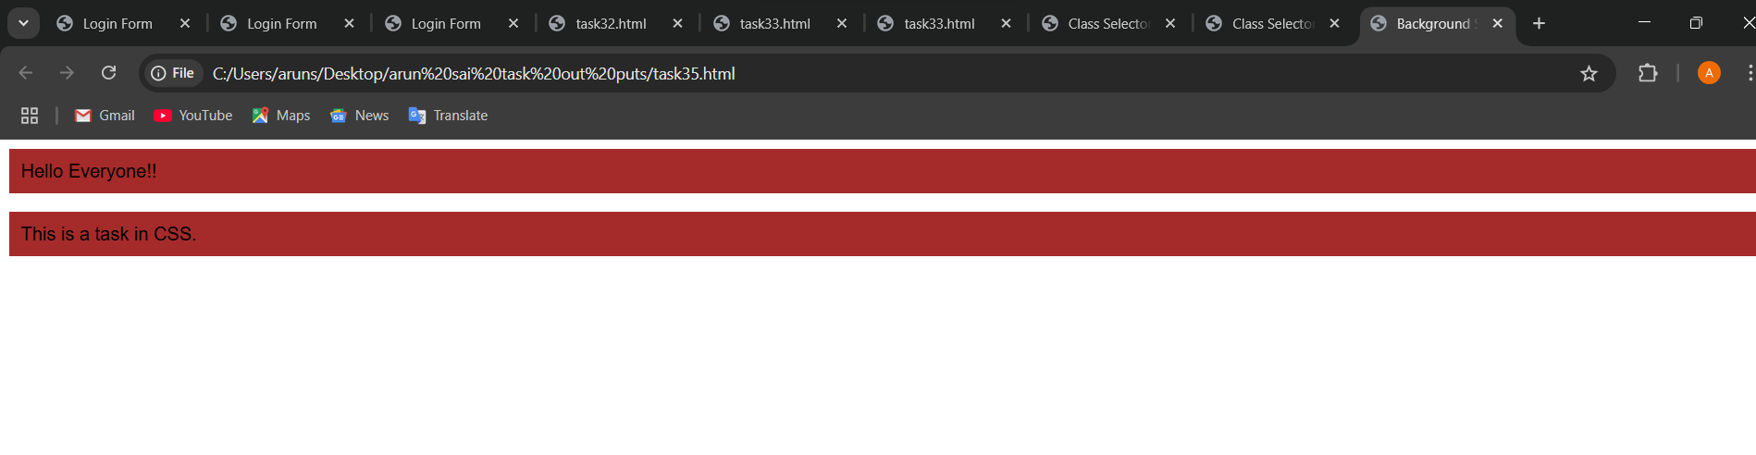

**TASK 36**

**36 Use a class selector to style elements with the following properties:**

**\* Set the border of the element to 2px solid black.**

**\* Change the width to 200px and height to 100px.**

**• Ensure these styles are applied to elements with this class**

**Souce code:**

<!DOCTYPE html>

<html>

<head>

<title>Box</title>

<style>

.box {

border: 2px solid black;

width: 200px;

height: 100px;

}

</style>

</head>

<body>

<div class="box">Segment 1</div><br></br>

<div class="box">Segment 2</div><br></br>

</body>

</html>

**Output:**

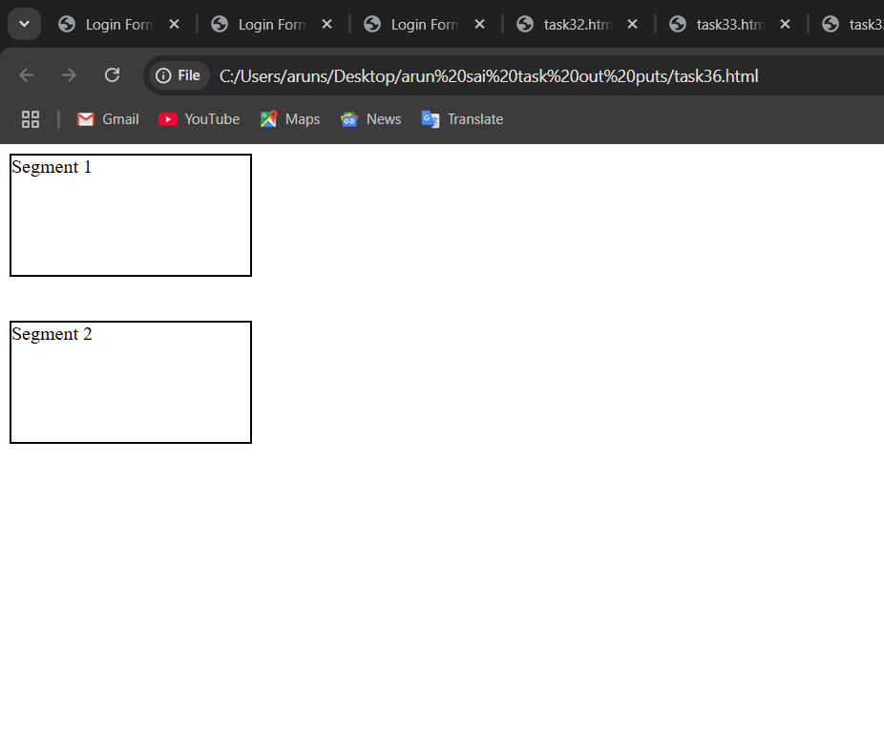

**TASK 37**

**37 Welcome Section Design**

**Question:**

**Design a webpage section with a large main title and a brief introduction**

**below it.**

**• The title should be bold and centered, while the introduction text should be**

**left-aligned with increased line spacing.**

**• Add a reset to remove any default spacing for the entire page.**

**Selectors to Use:**

**•* Type Selector: For the main title (make it bold and center-aligned).**

**•* Type Selector: For the introduction text (left-aligned, line spacing).**

**•* Universal Selector: For resetting default spacing (margin and padding)**

<!DOCTYPE html>

<html>

<head>

<title>Webpage Section</title>

</head>

<body>

<style>

/* Universal selector to reset default spacing */

* {

margin: 0;

padding: 0;

}

/* Type selector */

h1 {

text-align: center;

font-weight: bold;

margin-top: 40px;

}

/* Type selector */

p {

text-align: left;

line-height: 3;

margin: 20px;

}</style>

<h1>India Today</h1>

<p>India Today is a weekly Indian English-language news magazine published by Living Media India Limited.</p>

<p> It is the most widely circulated magazine in India, with a readership of close to 8 million.</p>

</body>

</html>

**Output:**

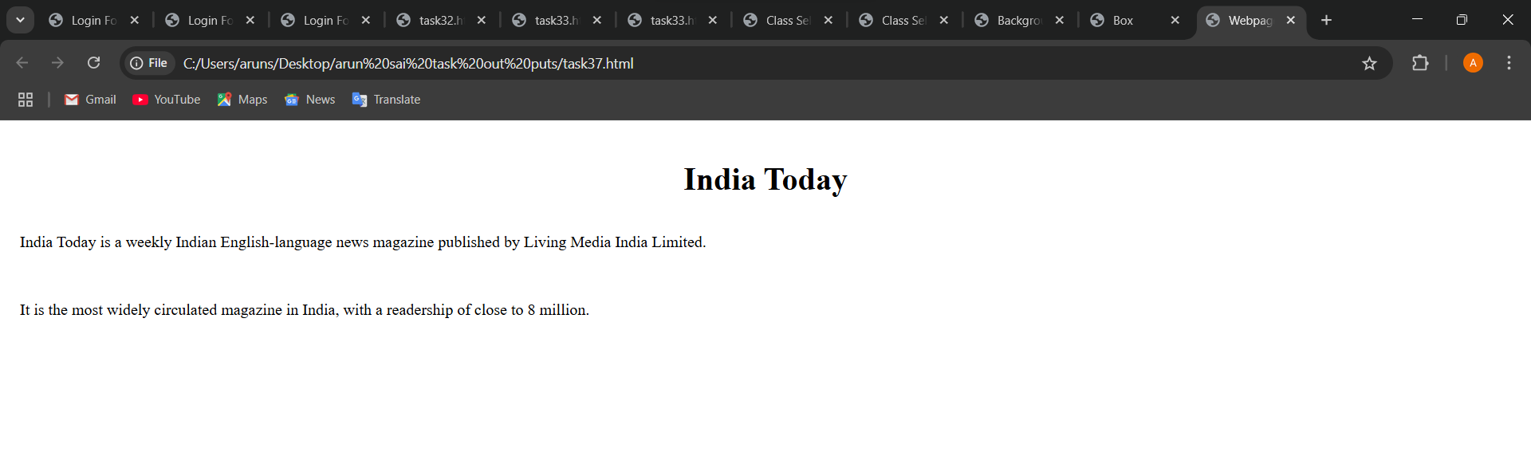

**TASK 38**

**38.Product Showcase**

**Question:**

**Create a card showcasing a product with an image, a product name, a brief**

**description, and a clickable button for purchase.**

**• The product name should be large and bold, while the description should be**

**in smaller text with a light background color.**

**• The button should have a hover effect, changing its background color.**

**Selectors to Use:**

**• *Type Selector: For the product name (large and bold).**

**• *Type Selector: For the description (smaller text with light background).**

**• *Class Selector: For the purchase button (hover effect with background**

**change).**

**• *Universal Selector: For consistent font style and box-sizing.**

**Source code:**

<!DOCTYPE html>

<html>

<head>

<title>Product Showcase</title>

<style>

* {

box-sizing: border-box;

font-family: Arial;

}

/* Product name - Type Selector */

h1 {

font-size: 24px;

font-weight: bold;

margin: 10px ;

color: blue;

}

/* Description - Type Selector */

p {

font-size: 14px;

background-color: white;

padding: 10px;

margin: 10px;

}

.buy-button {

background-color: red;

color: white;

padding: 10px 16px;

border: none;

border-radius: 4px;

cursor: pointer;

transition: background-color ;

}

.buy-button:hover {

background-color: white;

}

.product-card {

width: 300px;

border: 1px solid black;

padding: 14px;

border-radius: 7px;

text-align: center;

margin: 20px auto;

}

.product-image {

width: 50%;

height: auto;

border-radius: 5px;

}

</style>

</head>

<body>

<div class="product-card">

<img src="https://m.media-amazon.com/images/I/61JvFLHZ6NL._AC_UF1000,1000_QL80_.jpg" alt="Product Image" class="product-image">

<h1>iPhone 16 Pro</h1>

<p>iPhone 16 Pro features a Grade 5 titanium design with a new, refined micro-blasted texture.</p>

<button class="buy-button">Buy Now</button>

</div>

</body>

</html>

**Output:**

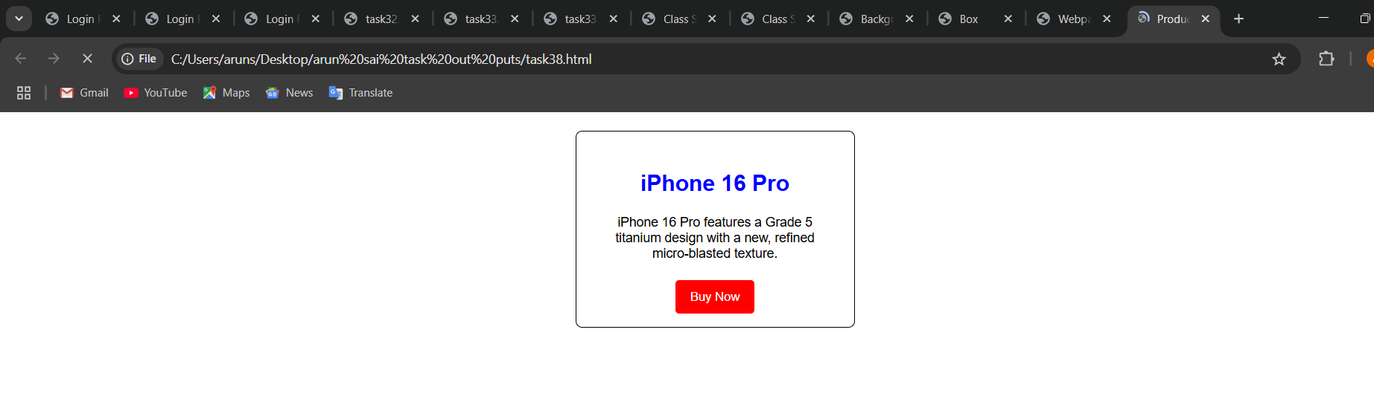

**TASK 39**

**39 Navigation Bar**

**Question:**

**Build a horizontal navigation bar with multiple clickable menu options. • Each option should change color when hovered.**

**• One of the options should appear highlighted as the active option.**

**Selectors to Use:**

**•* Type Selector: For the menu options (basic styling).**

**\* Class Selector: For the active menu option (highlighted). Class Selector: For hover effect on menu options (color change).**

**•* Universal Selector: For removing default margin and padding of the navbar.**

**Source Code:**

<!DOCTYPE html>

<html>

<head>

<title>Navigation Bar</title>

<style>

/* Universal Selector to remove default margin and padding */

* {

margin: 8px;

padding: 5px;

box-sizing: border-box;

}

/* Type Selector */

li {

list-style: none;

display: inline-block;

padding: 15px;

font-family: Arial;

cursor: pointer;

color: black;

}

/* Class Selector */

li:hover {

background-color: lightblue;

}

/* Class Selector */

.active {

background-color: green;

color: white;

}

nav ul {

background-color: yellow;

padding: 10px;

text-align: center;

}

</style>

</head>

<body>

<nav>

<ul>

<li class="active">Home</li>

<li>About</li>

<li>Services</li>

<li>Contact</li>

</ul>

</nav>

</body>

</html>

**Output:**

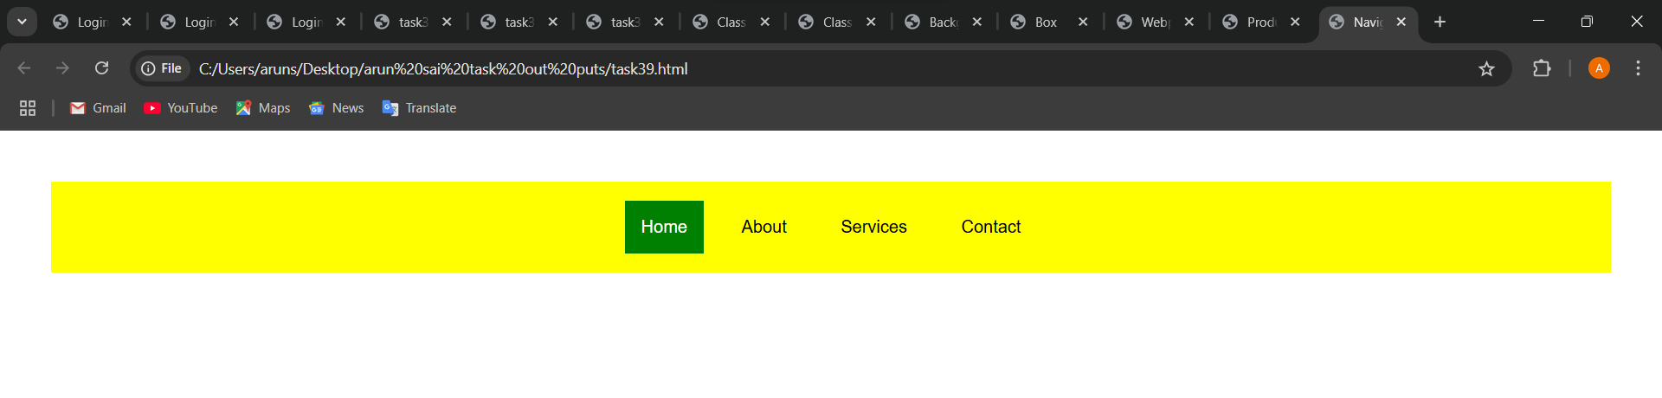

**TASK 40**

**40.User Profile Card**

**Question:**

**Design a card featuring a user’s profile picture, name, and a short bio.**

**• The name should appear prominently, and the bio should be in a smaller**

**font.**

**• Add a button below the bio that changes color when hovered.**

**Selectors to Use:**

**•* Type Selector: For the profile name (large font) and bio (smaller font).**

**• *Class Selector: For the button (hover effect with background change).**

**• *Universal Selector: For consistent padding and font style.**

**Source Code:**

<!DOCTYPE html>

<html>

<head>

<title>User Profile Card</title>

<style>

/* Universal Selector: for consistent padding and font style */

* {

margin: 0;

padding: 0;

box-sizing: border-box;

font-family: Arial; }

.profile-card {

width: 300px;

padding: 20px;

border: 1px solid ;

border-radius: 10px;

text-align: center;

background-color: white; }

.profile-img {

width: 100px;

height: 100px;

border-radius: 50%;

margin-bottom: 15px; }

/* Type Selector: Name*/

h1 {

color: green;

font-size: 20px;

margin-bottom: 10px; }

/* Type Selector: Bio */

p {

font-size: 14px;

color: grey;

margin-bottom: 20px;}

/* Class Selector: hover effect */

.profile-button {

padding: 10px ;

background-color: coral;

border: none;

border-radius: 5px;

color: white;

cursor: pointer; }

.profile-button:hover {

background-color: green; }

</style>

</head>

<body>

<div class="profile-card">

<img src="https://cdn.pixabay.com/photo/2015/10/05/22/37/blank-profile-picture-973460_1280.png" alt="User Profile Picture" class="profile-img">

<h1>Arun sai varma</h1>

<p>adjusting to new situationsand challenges with ease.</p>

<button class="profile-button">Follow</button>

</div>

</body>

</html>

**Output:**

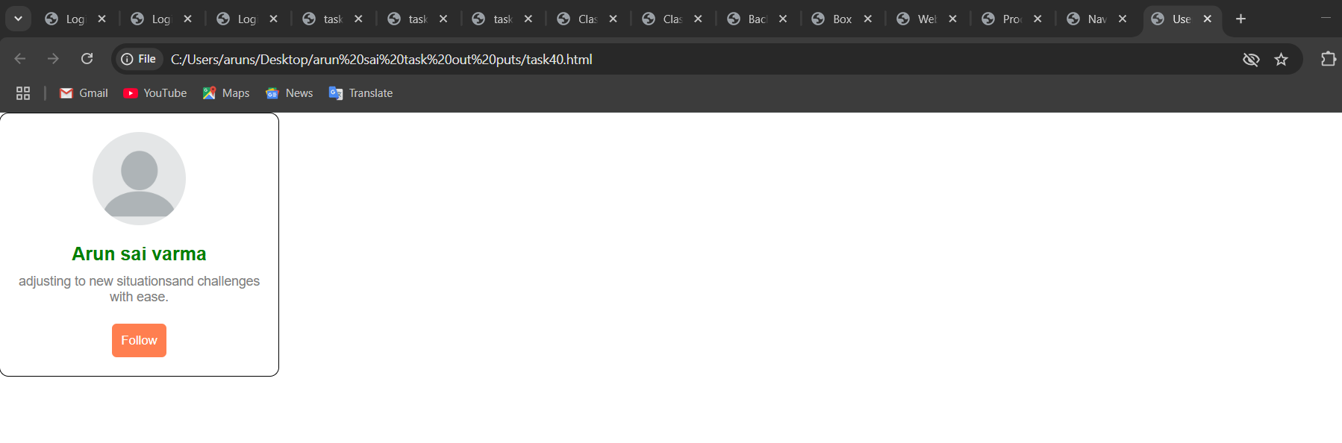

**TASK 41**

**41.Blog Layout**

**Question:**

**Design a blog layout with a main title, multiple blog posts with a title and**

**description, and a side section for additional information.**

**• The main title should be large and centered.**

**• The blog posts should appear stacked vertically, each with a bold title and**

**normal text below.**

**• The side section should be styled separately with a different background**

**color.**

**Selectors to Use:**

**• *Type Selector: For the main title (large and centered).**

**• *Type Selector: For the blog post titles and descriptions (bold for titles). *Class Selector: For the sidebar (different background color).**

**• *Universal Selector: For consistent font and layout.**

**Source Code:**

**<!DOCTYPE html>**

**<html>**

**<head>**

**<title>Simple Blog Layout</title>**

**<style>**

**\* {**

**box-sizing: border-box;**

**font-family: Arial, sans-serif;**

**margin: 0;**

**padding: 0;**

**}**

**body {**

**background-color: #f4f4f4;**

**}**

**h1 {**

**text-align: center;**

**font-size: 2.5em;**

**margin: 1em 0;**

**color: #333;**

**}**

**.container {**

**display: flex;**

**justify-content: space-between;**

**padding: 1em 2em;**

**gap: 1.5em;**

**}**

**.main-content {**

**flex: 3;**

**}**

**.post {**

**background-color: #fff;**

**padding: 1em;**

**margin-bottom: 1.5em;**

**border-radius: 5px;**

**box-shadow: 0 2px 5px rgba(0, 0, 0, 0.05);**

**}**

**.post h2 {**

**font-size: 1.4em;**

**font-weight: bold;**

**margin-bottom: 0.5em;**

**color: #222;**

**}**

**.post p {**

**font-size: 1em;**

**color: #555;**

**}**

**.sidebar {**

**flex: 1;**

**background-color: #e2e8f0;**

**padding: 1em;**

**border-radius: 5px;**

**height: fit-content;**

**}**

**.sidebar h3 {**

**margin-top: 1em;**

**margin-bottom: 0.5em;**

**color: #444;**

**}**

**.sidebar p {**

**font-size: 0.95em;**

**color: #333;**

**margin-bottom: 1em;**

**}**

**.sidebar ul {**

**list-style-type: disc;**

**padding-left: 1.2em;**

**}**

**.sidebar li {**

**margin-bottom: 0.5em;**

**color: #333;**

**}**

**@media (max-width: 768px) {**

**.container {**

**flex-direction: column;**

**}**

**.main-content, .sidebar {**

**width: 100%;**

**}**

**}**

**</style>**

**</head>**

**<body>**

**<h1>arun tech vlog</h1>**

**<div class="container">**

**<div class="main-content">**

**<div class="post">**

**<h2>Understanding CSS Flexbox</h2>**

**<p>Learn how to build flexible and responsive layouts using CSS Flexbox. Great for modern web design!</p>**

**</div>**

**<div class="post">**

**<h2>JavaScript Async/Await Explained</h2>**

**<p>A beginner-friendly look into how async functions work in JavaScript, with examples and use-cases.</p>**

**</div>**

**<div class="post">**

**<h2>Web Accessibility Tips</h2>**

**<p>Make your website usable by everyone. These tips will help you implement accessibility best practices.</p>**

**</div>**

**</div>**

**<div class="sidebar">**

**<h3>About This Blog</h3>**

**<p>This blog covers topics in front-end development, web accessibility, and best practices for clean code.</p>**

**<h3>Categories</h3>**

**<ul>**

**<li>HTML & CSS</li>**

**<li>JavaScript</li>**

**<li>Accessibility</li>**

**<li>Performance</li>**

**</ul>**

**</div>**

**</div>**

**</body>**

**</html>**

**Output:**

